**PESO San Julian MIS**

**DEPARTMENT OF INFORMATION TECHNOLOGY**

College of Computer Studies

Eastern Samar State University

Borongan City, Eastern Samar

In Partial Fulfillment of the Course Requirement for the Degree

**BACHELOR OF INFORMATION TECHNOLOGY**

Lisaca, Tirso Jr

Docel, Benidic G

Villones, Jake

**Chapter I**

**INTRODUCTION**

**Background and Rationale**

The Municipality of San Julian, located in the province of Eastern Samar, continues to strengthen its commitment to improving the welfare and opportunities of its constituents through education, employment, and digital innovation. Two key initiatives that contribute significantly to this goal are the Public Employment Service Office (PESO) and the local scholarship program. It serves as a bridge between job seekers and employment opportunities by offering job matching, referrals, labor market information, and skills training support. Meanwhile, the local government’s scholarship program offers financial assistance to deserving students, especially those from low-income families, as part of its efforts to promote access to higher education and uplift the socio-economic status of the youth.

However, both programs currently face limitations in terms of efficiency, accessibility, and transparency due to manual processes and the absence of integrated digital systems. The PESO relies heavily on paper-based records and face-to-face transactions, which often lead to delays in service delivery, difficulty in tracking beneficiaries, and inefficient reporting. Similarly, the scholarship program's manual application and evaluation process can result in bottlenecks, inconsistencies, and limited reach, particularly for students in remote barangays. These issues affect the responsiveness of the local government and hinder the full realization of its inclusive development goals. To address these challenges, the municipality proposes the development and implementation of a PESO Management Information System (MIS) . This digital platform aims to transform how the local government delivers education and employment services by automating key processes, improving data management, and making services more accessible to the public. The PESO MIS component will streamline functions such as client registration, job matching, employer profiling, event coordination, and real-time report generation. It will also improve coordination with national agencies like DOLE and TESDA and enable the office to make evidence-based decisions based on updated labor market data.

On the other hand, the Scholarship will digitize the entire scholarship lifecycle from online applications and beneficiary tracking and report generation. This will enhance transparency, minimize errors or duplication, and ensure that educational assistance reaches the most qualified and deserving students efficiently. By making the system accessible through mobile and online platforms, the local government can ensure wider coverage, particularly for those in geographically isolated areas.

Local scholarship programs, which are intended to promote access to higher education for underprivileged youth, are often hampered by unclear guidelines, manual processes, and weak documentation systems. This makes it difficult to track beneficiary performance, monitor fund utilization, and assess the long-term impact of such programs on employment outcomes (De Vera, 2020). Moreover, there is a lack of integration between education support services and employment facilitation mechanisms. As a result, valuable data that could guide policy such as the educational backgrounds of student , their employment outcomes

Despite the mandates and efforts of local government units (LGUs) to promote inclusive access to employment and education, municipalities of San Julian continue to rely on manual, paper-based systems and the student cant track their status in the management of public employment and scholarship programs. This outdated approach results in inefficient data handling, delayed service delivery, and limited monitoring and evaluation capabilities (Aguinaldo, 2021). While the Public Employment Service Office (PESO) is required under Republic Act No. 10691 to institutionalize labor market information systems at the local level, many PESOs across the Philippines still lack the technological infrastructure and capacity to fully implement these requirements (Department of Labor and Employment [DOLE], 2020).

**Objectives of the study**

The main objective of this study is to design and develop a comprehensive, web-based PESO San Julian MIS that enhances the accessibility, efficiency, and transparency of the scholarship application and management process for the Local Government Unit of San Julian.

The study aims to**:**

1. Provide a notification system that informs applicants about the status of their application and important updates.
2. Enable scholarship administrators to review, approve, and manage applications digitally
3. Create an administrator dashboard where authorized personnel can review, filter, and manage applications efficiently.
4. Design an online platform that allows students to easily submit scholarship applications
5. Improve accessibility and outreach of the scholarship program, especially for students in remote or underserved areas.
6. Enable the system to generate comprehensive reports on application statistics, including the number of applicants, approval and rejection rates
7. Allow document uploads for students to attach necessary files such as IDs, academic records, and certificates as part of their application.

**Scope and Limitations**

This study focuses on the design, development, and implementation of the PESO Julian MIS for the Local Government Unit (LGU) of San Julian, with the goal of improving the scholarship application and management process through the use of digital technology.

**Scope:**

1. The system will be accessible online,
2. LGU administrators can review, approve, reject applications
3. The system includes a notification and alert feature to inform applicants about: Application status updates (Approved, Rejected)
4. The platform will prioritize security, ensuring that all applicant data is stored securely
5. The system will have different access levels for users, including students (applicants) and administrators,
6. The system will support scholarship/summer job (Tulong Dunong Program, Transportation allowance, special program for employment of student SPES)
7. The system will include a document upload feature, allowing applicants to submit required files such as identification documents, certificates, or recommendation letters during the application process.

**Limitations:**

1. The system requires an internet connection for users to access the platform.
2. Students and administrators will need a basic understanding of using web-based systems and devices (computers, smartphones) to access the platform.
3. The system will not handle other administrative functions such as student enrollment, academic record keeping
4. System will not allow the automatically verify validity of the application
5. Users (students or administrators) will not be able to customize the platform interface or add functionalities without developer support.

**Significance of study**

This study lies in its potential to transform the scholarship application and management process in San Julian, making it more efficient, accessible, and transparent. the benefits of this system extend to administrators, students, and the community as a whole,

**Local Government Unit (LGU) of San Julian**

This study PESO San Julian MIS offers the LGU an effective tool for managing and overseeing scholarship applications digitally, the system will minimize administrative burdens, reduce the chance for errors. The ability to track and manage applications efficiently will help the municipality ensure the fair distribution of scholarship resources. Additionally, the system will generate valuable reports and insights, allowing the LGU to make informed decisions and improve future scholarship initiatives. This digital transformation aligns with the municipality’s broader goals of promoting good governance and fostering transparency in public service.

**Student**

This study PESO San Julian MIS will provide students, especially those from remote or underserved areas, with a convenient, accessible, and transparent way to apply for scholarships.

**Researchers**

This study provides a significant contribution to the field of digital governance and educational support systems. The findings from this study can serve as a valuable resource for understanding how digital tools can be leveraged to solve challenges in public sector management, specifically in scholarship distribution.

**Future Researchers**

This study will serve as a foundational resource for future researchers interested in the application of digital platforms in the public sector, particularly in education and scholarship management. Future researchers can build upon this study by evaluating the long-term impact of the PESO MIS in San Julian,

**Definition of terms**

Beneficiary An individual who receives services or assistance from a government program. In this context, it refers to job seekers served by PESO and students supported by the local scholarship program.

Beneficiary Tracking The ongoing monitoring of individuals who are receiving services or aid, such as employment assistance or scholarship funds, to ensure they meet requirements and achieve intended outcomes.

Client Profiling The process of collecting and analyzing information about clients to provide personalized and targeted services. In PESO, profiling includes skills, education, employment history, and job preferences

Data are values of qualitative or quantitative variable, belonging to a set of items

Database an organize collection of data. The data are typically organized to model relevant aspects of reality in a way that supports processes requiring this information

Digital Governance The use of information and communication technology (ICT) by government institutions to improve service delivery, transparency, and citizen engagement. The proposed system is an example of digital governance in local administration.

Government is the system by which state or community is governed

Local Government Unit (LGU) Refers to a political subdivision in the Philippines such as a province, city, municipality, or barangay. In this study, LGU pertains to the Municipality of San Julian, which is responsible for implementing the proposed system.

Management Information System (MIS) A computerized system designed to collect, store, manage, and analyze data to support decision-making and improve the efficiency of organizational operations. In this study, it refers to a digital platform for automating PESO processes in San Julian.

Manual operated by a person rather than a machine or computer, or by human effort rather than electricity or another types of power

Monitoring and Evaluation A systematic process used to assess the performance and outcomes of a program. The MIS and Scholarship system can track usage, success rates, and compliance.

Online Dashboard A visual interface within a system that shows key data, statistics, or trends in real-time. The PESO or scholarship coordinator can use this to make fast, informed decisions.

PESO (Public Employment Service Office) A non-fee charging multi-employment service facility or office established in local government units (LGUs) to provide employment services such as job matching, skills training, and labor market information. It operates under the supervision of the Department of Labor and Employment (DOLE).

Report to give detailed information about research or an investigation

Stakeholders Individuals or groups who have an interest in the project. In this study, stakeholders include students, job seekers, PESO staff, LGU officials, and education or labor partners

Transparency The practice of openly and clearly disclosing information and processes to stakeholders. The digital platform aims to promote transparency in scholarship awards and employment services

User Authentication The process of verifying a user’s identity before granting access to a system or account. It ensures that only authorized users can access as sensitive data in the PESO MIS or Scholarship platform.

**Chapter II**

**Review of Related Systems**

This chapter primarily presents various studies, both foreign and local, which are significant to the variables included in this research. The literature reviewed in this study comes from books, journals, articles, and electronic sources such as (PDFs). These sources are believed to enhance understanding and awareness concerning the focus of this study.

Public Employment Service Offices (PESOs) play a crucial role in implementing labor market programs and promoting employment (Bachita & Bayoneta, 2021). While these services have shown high levels of implementation, there is a need for local laws to enhance employment facilitation (Bachita & Bayoneta, 2021). Management Information Systems (MIS) are essential for improving the effectiveness and efficiency of employment support systems, particularly for individuals with disabilities (Migliore et al., 2021). The implementation of digital-based systems in government services can lead to increased efficiency, fairness, and accountability (Nur & Novarina, 2020). However, the adoption of website-based MIS for public services has shown mixed results, with some studies indicating that while it may improve employee work effectiveness, it may not fully meet public needs (Sultan, 2023). Overall, the integration of MIS in public employment services presents both opportunities and challenges for enhancing service delivery and employment outcomes.

In Davao City, the Educational Benefit System Unit (EBSU) was developed to automate the city’s scholarship processes. This system included key functions such as applicant tracking, document verification, and approval workflows, effectively reducing manual workload for administrators (IJETT, 2024). Likewise, a Scholarship ManagementSystem with SMS Notification, proposed by researchers in 2022, emphasized the importance of real-time communication between scholarship coordinators and applicants.

The system proved effective in improving transparency and engagement (IJEI, 2022). Meanwhile, in the Municipality of Rosario, Batangas, a PESO Job Portal was developed to digitize job postings, applicant profiles, and employer coordination. The portal helped minimize walk-in traffic and manual processing, and served as a valuable digital hub for employment services at the municipal level (IJARP, 2021).

the, developed by the Department of Labor and Employment (DOLE), serves as a centralized database of active manpower supply. It contains profiles of job seekers and employers, facilitating efficient job matching and providing labor market information. The PEIS is maintained largely by LGUs and is linked to DOLE's regional and central offices, constituting a national employment service network (Department of Labor and Employment, 2020).

Another system that highlights digital innovation in employment services is the Baguio City PESO Digital Employment Services, launched in 2022. This system integrates job matching, training registration, and employer profiling into a single platform accessible to constituents via a web and mobile app. It also allows PESO staff to generate reports for monitoring employment trends and program effectiveness. This approach supports the city’s commitment to delivering responsive and efficient public employment services (Baguio City Government, 2022).

The Quezon City PESO Management System, launched in 2021, provides an integrated platform for job seeker registration, employer profiling, and job matching. It allows the city’s PESO staff to track employment referrals and training programs digitally, significantly improving turnaround times and reducing paperwork (Quezon City Government, 2021). This system also integrates labor market data from the Department of Labor and Employment (DOLE), enabling local PESO staff to make evidence-based decisions and provide timely labor market information.

According to Ranjitha V, & Swamydoss D. (2022), a job portal is used for job seekers to find available job vacancies according to their Education Qualification, skill, experience, and location. Companies can identify eligible job seekers and it is the best way to select the best-qualified candidate-job portal is the solution for recruiters as well as job seekers to fulfill their requirements. Job seekers can register the application and update their profile, skills, and experience, Job seekers can search the available jobs and apply for their desired positions

Similarly, the (2022) improved client profiling and employer engagement by allowing online job postings and automated matching features, reducing delays in job referrals and facilitating remote access for clients in geographically isolated areas (Zamboanga City Government, 2022).

Various digital systems have been developed to address the challenges of manual scholarship management. Cruz and Reyes (2022) created an E-Scholarship System that digitizes submission, approval, and monitoring processes for local government units. Bautista and Flores (2021) designed the Online Scholarship Application and Record Management System for AYZ City, offering secure data handling and status update features to reduce administrative workload. Francisco and Moreno (2022) proposed an Online Scholarship Management System for Camarines Sur Polytechnic Colleges, aimed at improving application processing through a centralized and user-friendly web platform. focused on real-time monitoring and transparency of scholarship disbursement for marginalized students in the region. Additionally, Edukasyon.ph (Springer, 2021) offers a Philippine-based online portal that connects students with universities, scholarships, and career pathways, promoting informed decision-making through digital access

Locally, there have also been smaller-scale scholarship management systems implemented in some municipalities and universities. the Iskolar ng Bayan online scholarship system introduced by the City Government of Valenzuela aims to remove the cumbersome process of manual application. the system integrates a student dashboard, real-time notifications, and digital submission of documentary requirements, significantly lowering the chances of document loss or delays (Valenzuela City Official Website, 2022)**.**

the Bacolod City PESO Job Portal (2023) integrates features like career counseling scheduling, employer profiling, and training referrals, providing a comprehensive platform that supports employment facilitation and labor market information dissemination within the local community (Bacolod City Government, 2023).

Internationally, various employment information systems serve as benchmarks for the development of the PESO MIS in the Philippines. In the European Union, Eurostat’s Labor Market Information System compiles detailed statistics from member states, enabling data-driven labor market policy and planning (European Commission, 2023). Australia’s Job active platform connects jobseekers and employers through an integrated online system supported by government employment services (Australian Government Department of Employment and Workplace Relations, n.d.).

According to Capinig, Godoy, et. Al. (2023), scholarship grantees are pleased for the wonderful program under the Commission on Higher Education (CHED), which has reduced their stress because the subsidy has an impact on their educational expenses. They are one step closer to attaining their dreams and receiving their college degrees as a result of this platform. Furthermore, as a result of this program, the participants are making attempts to stay, and the graduating students keep continuing and going. The participants’ families are also delighted that the program can give their children with a free and high- quality education.

These programs are part of the national agenda to promote social mobility and economic growth by building a skilled workforce. however, the rising costs of education including tuition, books, and other necessities continue to pose challenges for many families (Jibrin et al.2020). despite the importance of these scholarships, the manual processing methods still in use hinder the timely distribution of benefits and present obstacles for applicants, particularly those in remote areas. shifting to digital platforms can address these issues by improving efficiency, minimizing errors, and expanding access to scholarship opportunities.

According to Internet has become the means for conducting growing numbers of transactions because of the speed, flexibility, and efficiency that it offers. this Technology is required by every organization if it does want to reach out to its customers in this age of globalization. the term “scholarship” is a form of financial assistance that does not require repayment or employment and which is usually offered to students who show potential for distinction, or who possess certain characteristics important to the scholarship provider (such as religious beliefs, hobbies, ethnicity, etc.).

However, the rising cost of education has made it increasingly difficult for low-income families to send their children to school, as they struggle to afford tuition and other educational expenses (Mohammed Abdullahi Jibrin et al.). Scholarships are crucial in providing financial support and making education more accessible by reducing financial burdens, such as tuition and living costs.

The Government, through agencies like the Commission on Higher Education (CHED), has implemented various scholarship programs to help low-income students pursue tertiary education and reduce dropout rates (CHED, 2023). these programs are part of the national agenda to promote social mobility and economic growth by building a skilled workforce. However, the rising costs of education – including tuition, books, and other necessities – continue to pose challenges for many families (Jibrin et al., 2020).

As technological innovation rapidly grows in technology and education, scholarship offices manage educational assistance that helps students continue their studies. most admin and scholarship officers of various scholarship programs use traditional ways of managing scholarship programs. Traditional keeping records of documents and requirements can be misplaced, and finding records is also a tedious job. therefore, (Albert V. Paytaren Hazel G. Gonzales Rhannel D. Dinlasan) came up with making a web application for managing educational assistance, which helps scholarship officers in collecting and managing information of scholars as well as for scholars to easily apply and submit requirements.

A scholarship Is a form of financial aid that is specifically geared towards students who are attending college. It is used as a way of financing their education, and it may pay a part of their education, or it may pay the entire cost of a student’s tuition. As point out, scholarships will require students to meet certain requirements, both before and after they’ve obtained It. most of these scholarships will require students to have a minimum GPA, and they may also require them to take a certain number of credit hours within the first 12 months of Their the importance of digital transformation in scholarship application and management systems, Bisen and Sahu (2021) designed an Advanced Application System for Student Scholarship using content-based filtering technique, aiming to automate and personalize scholarship matching based on applicant qualifications. Similarly, Dhal and Panda (2024) discussed the integration of Natural language Processing (NLP) into E-Scholarship platforms to help reduce manual errors and speed up application reviews. lastly, research by Jibrin et al. (2020) analyzed the ongoing struggles of Filipino students, noting the importance of digital tools in bridging scholarship opportunities to marginalized sectors.

In this paper. Isbudeen Noor Mohamed, Ahmad Tasnim Siddiqui, Syed Ajaz, S. Mohamed Idhris, “Student Information Report System with SMS (SIRS), in proc. 2020 system has come up with many advantages for educational institutions to track the student development and administration attendance. It helps equally student and protector to keep track of student improvement without visiting to the college.

Manual processes further disadvantage students with mobility issues or those living far from institutions, making timely submission of applications difficult. Bicol University, for instance, has recognized the importance of addressing these lmitations by partnering with organizations like the Tzu Chi Foundation to enhance access to scholarships through digital means. these efforts reflect a growing need for online scholarship management systems to improve efficiency, security, and accessibility for both administrators and students in the region (Bicol University, 2023; Commission on Higher Education, 2022).

Several studies have explored the development of e-scholarship systems to improve how students apply for and receive scholarships. These systems are designed to make the process faster, more accurate, and easier for both students and administrators. Karthikeyan and Suganthi (2024) introduced a student students application system integrating NLP with e scholarship platform that uses Natural Language Processing (NLP) to help match students with scholarships based on their qualifications and needs. Their system reduces the time students spend searching for opportunities and also helps administrators by automatically sorting and filtering data, making the review process more efficient.

Similarly, Ghosh and Roy (2023) developed a scholarship automation system that uses regression analysis to check student qualifications. Their system can predict student eligibility and suggest suitable scholarships, helping schools save time, avoid manual errors, and ensure a fairer selection process.

The study of (Gonzales et al., 2020) utilizes the design and development of the website since it focuses on online application and detection of the scholarship granted to the scholars. The respondents of the study are the regular users of the scholarship office. It provides all the information that the scholarship office can give to scholars regarding the status of scholarship grants and how they will apply online.

Fajardo et al. (2024) implemented a machine learning-based approach to predict scholarship grants for the Davao City Educational Benefit System Unit (EBSU). By utilizing algorithms such as Logistic Regression, Support Vector Machine, Multilayer Perceptron, Naïve Bayes, and Random Forest, the system effectively matched applicants with suitable scholarship programs based on their backgrounds and qualifications. This data-driven method improved the selection process’s efficiency and fairness, ensuring that financial aid reached the most deserving candidates.

Santos and Mendoza (2021) developed an Educational Assistance Management System for Batangas State University to improve the accuracy and security of student scholarship records through automation, highlighting how moving from manual to digital systems allows educational institutions to improve efficiency, fairness, and accessibility for students, especially in remote areas.

Locally, there have also been smaller-scale scholarship management systems implemented in some municipalities and universities. the Iskolar ng Bayan online scholarship system introduced by the City Government of Valenzuela aims to remove the cumbersome process of manual application. the system integrates a student dashboard, real-time notifications, and digital submission of documentary requirements, significantly lowering the chances of document loss or delays (Valenzuela City Official Website, 2022)**.**

An online scholarship application and record management system for an agency to eliminate the manual process of managing and profiling the scholars’ information, scholarship approval, and notification. the main focus of the system is to improve the manual method that the said client uses, and for rapid processing of transactions. furthermore, having an application and record management system may lessen manpower and results to more secured, reliable, and more organized storage of data. the developed system used Microsoft html java phpn as their programming language. they also used XAMMP for the back-end database to serve as a repository of all records. the developed system enabled the users to update their personal information, submit their credentials and view the current status of their scholarship. there is also a module provided for the administrator where the administrator can easily approve and disapprove applicant scholars and can effortlessly set schedule. (Malipol et al., 2020).

In a study by Isbudeen Hamed, Ahmad Tasnim Siddiqui, Syed Ajaz, and S. Mohamed Idhris (presented at ICCCI 2021), the Student Information Report System (SIRS) was designed to facilitate seamless data exchange among students, faculty, parents, and educational institutions. This system aimed to enhance communication and improve the efficiency of information dissemination within academic environments.

A review of related scholarship management systems reveals that most existing platforms, such as those studied by Paytaren et al. (2020) and Cruz and Reyes (2022), primarily focus on facilitating online application submissions and basic administrative review. These systems often include essential features such as digital application forms and centralized record-keeping but tend to vary in terms of user accessibility, notification systems, and data security protocol.

Some advanced systems, such as those introduced by Ghosh and Roy (2023) and Dhal and Panda (2024), explore the integration of artificial intelligence techniques like natural language processing (NLP) and predictive filtering for eligibility assessment. These features, while sophisticated, may require significant computational resources and technical infrastructure that are not always feasible for local government unit (LGU) funded programs in rural municipalities like San Julian.

The PESO MIS in San Julian distinguishes itself by placing strong emphasis on accessibility, especially for applicants from remote and underserved areas, and by providing real-time notification alerts to both students and administrators a feature that is either absent or only partially implemented in related systems. Furthermore, while several systems in the literature mention administrative dashboards, the proposed system enhances this by incorporating role-based access and an intuitive user interface optimized for both desktop and mobile devices, ensuring inclusivity for users with limited technological resources.

The PESO San Julian MIS uniquely supports LGU decision-making by providing automated reporting tools for scholarship trend analysis and fund allocation a governance centered feature that is often overlooked in other systems which focus mainly on application processing.

The PESO San Julian MIS addresses practical gaps in accessibility, transparency, and administrative support, customizing its design to the needs of San Julian’s local scholarship program.

**Chapter III**

**Software Development Model**

The System Development Life Cycle (SDLC), also referred to as the application development life cycle, is a term used in system engineering information systems and software engineering to described a process for planning, creating, testing and deploying an information system (Elliott & Strachan & Radford). Is a structured process that is used to design, develop, and test good-quality software. SDLC, or software development life cycle, is a methodology that defines the entire procedure of software development step by step. The goal of the SDLC life cycle model is to deliver high-quality, maintainable software that meets the user’s requirements. SDLC in software engineering models outlines the plan for each stage so that each stage of the software development model can perform its task efficiently to deliver the software at a low cost within a given time frame that meets users requirements. In this article we will see Software Development Life Cycle (SDLC) in detail.

The Agile model Is a project management approach that prioritizes flexibility and feedback throughout the development process, making it a good choice when these factors are high priorities. It’s an iterative method that focuses on continuous improvement and rapid delivery of incremental value. Unlike traditional methods, Agile focuses on delivering incremental value through iterative development, allowing researcher to adapt quickly to changes and incorporate customer feedback.

The researchers use Agile Model as their software development model because they meet the requirements needed and the following functions iterative development, continuous feedback, and adaptability to change. Agile promotes close collaboration between developers and the scholarship of the municipality of San Julian, enabling the researcher to respond quickly to evolving user needs and technical challenges. Through short development cycles called sprints, Agile allows for incremental progress and regular testing, ensuring that each feature is functional and aligned with the user expectations.

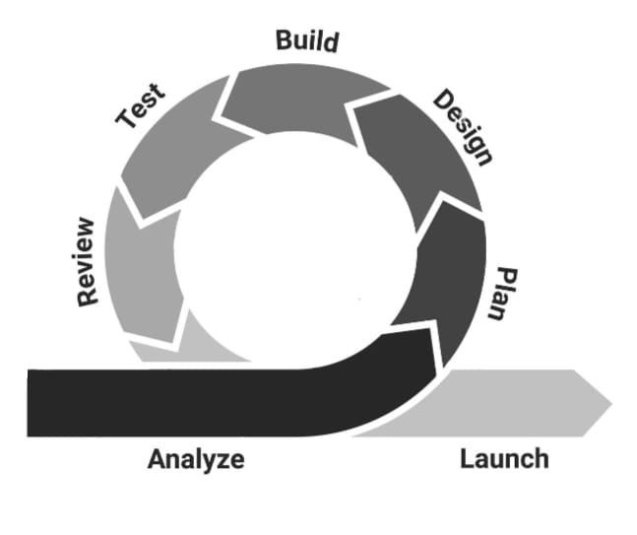

**Figure 2.0:** Agile model

**Planning phase**

In this phase, the researcher is assembled, which usually includes software developers, testers, designers, and project managers. Together, they prioritize the user stories and decide which features should be developed first based on importance and complexity. The researcher also estimates the time, budget, and resources needed for each feature. In the PESO San Julian MIS, the team might prioritize creating the user registration and login modules before moving on to more complex features like application review and document verification.

**Design phase**

In this phase, system architectures, mockups, and user interfaces are designed for the planned features. the designs are kept simple and flexible to accommodate changes in future sprints. for the PESO San Julian MIS, this might involve sketching out the layouts for the login page, the dashboard, and the scholarship application form. the designs are then reviewed to ensure that they meet both functional and aesthetic standards before development begins.

**Build phase**

In this phase where coding and integration happen. Developers start building the features as planned in the sprint backlog. they work collaboratively and attend daily stand-up meetings to share updates, discuss any challenges, and ensure that stays on track. during the development of the PESO San Julian MIS, the researcher would code the registration process, create backend services for user authentication, and connect the database to the login form. This approach ensures that progress is steady and transparent.

**Testing phase**

In the Testing phase, the PESO San Julian MIS is systematically evaluated to ensure it meets all specified requirements. the researcher verifies that individual components, such as user authentication modules or database connections, function correctly in isolation. The researcher evaluates the complete, PESO San Julian MIS to confirm it meets the overall functional and non-functional requirements.

**Release phase**

In this Phase, the system is prepared for installation and operational use by the intended users. all necessary configurations, documentation, and training materials have been completed to ensure a seamless transition from development to deployment. the system has undergone rigorous testing

**The Feedback and Review phase**

This phase, the staff of PESO in charge review the new functionalities and provide feedback. the researcher also reflects internally on what went well, what challenges were faced, and how to improve future phase. after reviewing the first release of the PESO San Julian MIS, the scholarship administrators might request the addition of a Forgot Password feature, and the researcher would include it in the planning for the next sprint.

**Planning**

In this phase, we will discuss the planning phase involved in the development of the PESO San Julian MIS. Effective planning ensures the project is feasible, well structured, and aligned with the goals of PESO applications, evaluations, and awards through an online platform. The planning phase served as the blueprint for the entire project, ensuring that all activities were aligned with the system’s goals and that development proceeded in a structured, efficient, and goal-driven manner.

**Requirements Specifications**

The requirements gathering phase aimed to identify both functional and non-functional needs. Functional requirements focused on the core capabilities of the system such as enabling students to register, apply for scholarships, upload supporting documents, track application status, and receive notifications. For administrators and scholarship committees, the system needed to support tasks such as reviewing applications, verifying eligibility, managing scholarship data, Before the system development, it was essential to gather and analyze all the requirements needed to build an efficient PESO San Julian MIS. This process included identifying the needs of students, administrators, scholarship committees, and other stakeholders.

User registration and login (students, administrators, evaluators)

Scholarship posting and application management

Document upload and verification

Status tracking (application submitted, approved, rejected)

**Operational Feasibility**

An Ishikawa diagram is a diagram that shows the causes of an event and is often used in manufacturing and product development to outline the different steps in a process, demonstrate where quality control issues might arise, and determine which resources are required at specific times. (A. Hayes, 2019).

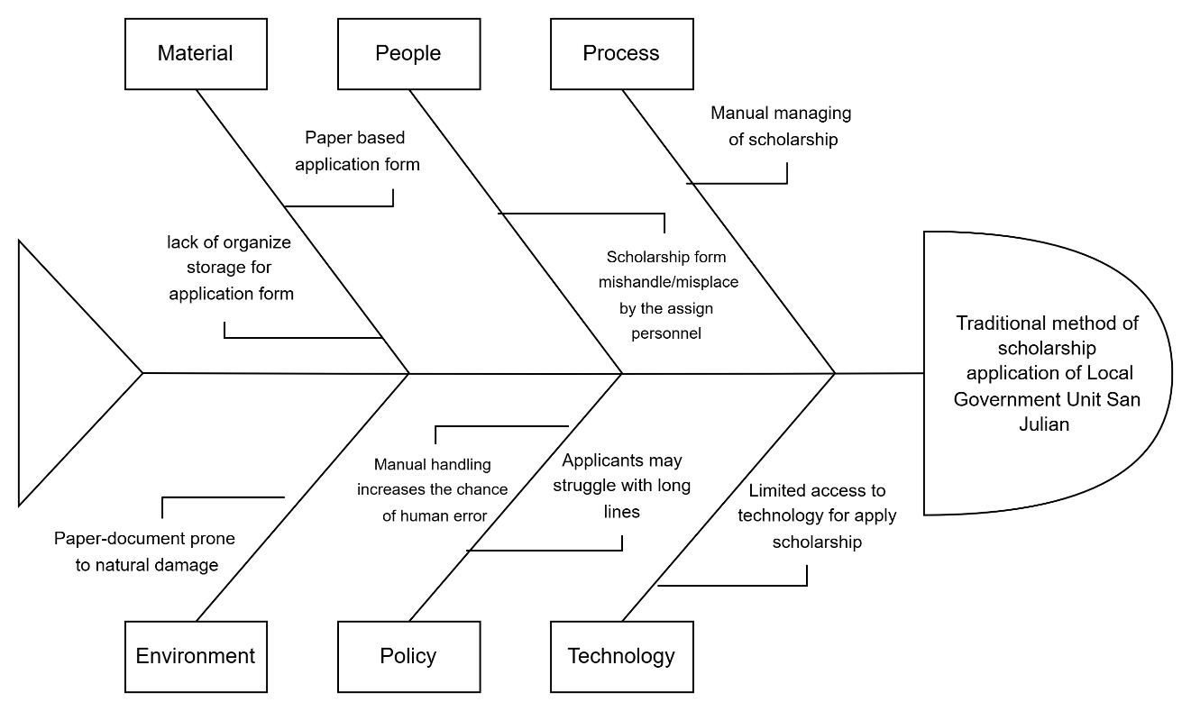

**Figure 2 Fishbone Diagram**

**Figure 2:** illustrates the focus of the researchers on a prevalent issue within the scholarship application of San Julian E Samar

The researchers used Ishikawa diagram in identifying the possible root of the problem faced by the Municipality of San Julian. This technique is used to be able to identify possible solutions to the problem that will be identified.

**Technical Feasibility**

This section discusses the necessary hardware and software specifications needed in the development and implementation of the system.

**Table 1. Software Specification (Development)**

|  |  |
| --- | --- |
| Software | System Minimum Requirements |
| Visual Studio Code | v1.97.2.0  HTML, CSS, JavaScript, & PHP |
| XAMPP | XAMPP v7.1.1-0 (PHP to 7.1.1, Apache 2.4.25, SSL 1.0.2j, MariaDB 10.1.21) |
| Database | XAMPP v7.1.1-0 (PHP to 7.1.1, Apache 2.4.25, SSL 1.0.2j, MariaDB 10.1.21 |
| Web Browser | Google Chrome on Windows Version 135.0.7049.115 (Official Build) (64-bit) |

**Figure 3.0:** Software Specification; the researchers used Visual studio code for the codes and Xampp for the database for the development of their study

**Table 2. Software Specification**

|  |  |  |  |  |
| --- | --- | --- | --- | --- |
| Software | System Minimum Requirement | Organization/Client  Technical Specification | Compatibility  (Yes or no) | Solution |
| Web Browser | Google Chrome on Windows version 135.0.7049.115 | Google Chrome on Windows version 78.0.3904.87 | Yes |  |

**Figure 3.1.** Software Specification; the researchers used web browser for the connection of the end user to the server for implementation of their study

**Schedule Feasibility**

Schedule feasibility is defined as the study that assesses how likely a project is to be completed within its proposed timeframe

**Gantt chart**

A Gantt chart is a graphical depiction of the project schedule. It’s a type of bar chart shows the start and finish dates of several elements of a project that include resources, milestones, tasks, dependencies. Henry Gantt, an American mechanical engineer, designed the Gantt chart.

**Figure Definition**

**Symbol Description**

Indicates the start and finish dates of the finished task.

Shaded Box

Indicates the start and finish dates of the unfinished task.

Unshaded Box

Represents the number of months for the completion of the project. It starts from January up to December. Each month corresponds to the duration of activity.

Vertical Line

Represents the series of activities to be done in the system improvement schema.

Horizontal Line

|  |  |
| --- | --- |
| **Task** | **Month**  Mar Apr May June July Aug Sep Oct Nov Dec |
| Planning |  |
| Designing |  |
| Developing |  |
| Testing |  |
| Deploying |  |
| Review/  Feedback |  |

**Figure 4** Gantt chart

In figure 4 is the Gantt chart which represents the phases of the Agile Model as a basis to show each activity needed by the proponent to take up in order to come up with organized project estimated task duration in fulfilling the whole proposed study. The figure shows when the proponent did started each activity and when will the activity end. It doesn’t only represent task duration but it also serve as the proponent’s guide in conducting the proposed enrollment and scheduling system. The phase is named into six categories namely the planning ,system design, develop, system testing, deploy review, launch. At the start of the study, the proponent taken up the first phase which is the requirement analysis where the proponent gathered information’s related to PESO San Julian MIS of San Julian better understand and learn relevant issues arises within their respective office. Several interviews and thorough investigation was conducted by the proponent which leads it to be establish in the statement of the problem which totally mold its objectives to continue the study of PESO San Julian MIS.

**Output and User Interface**

The system provides outputs such as application status updates, notifications, while offering a user-friendly interface designed for students, administrators, and, featuring dashboards, application forms, tracking their status of application, and document management options.

**Home Page**

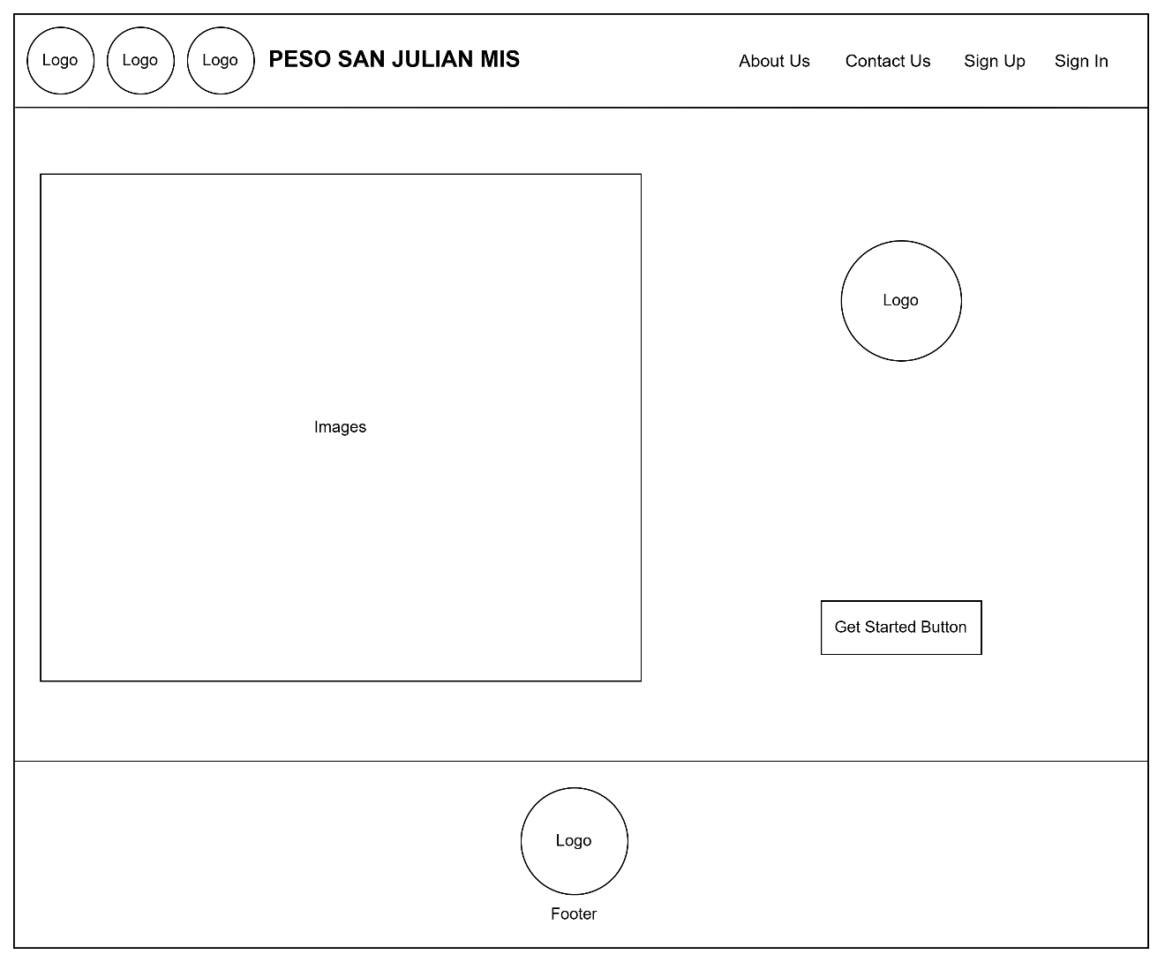

**Figure 5:** Home page

**Sign In Page**

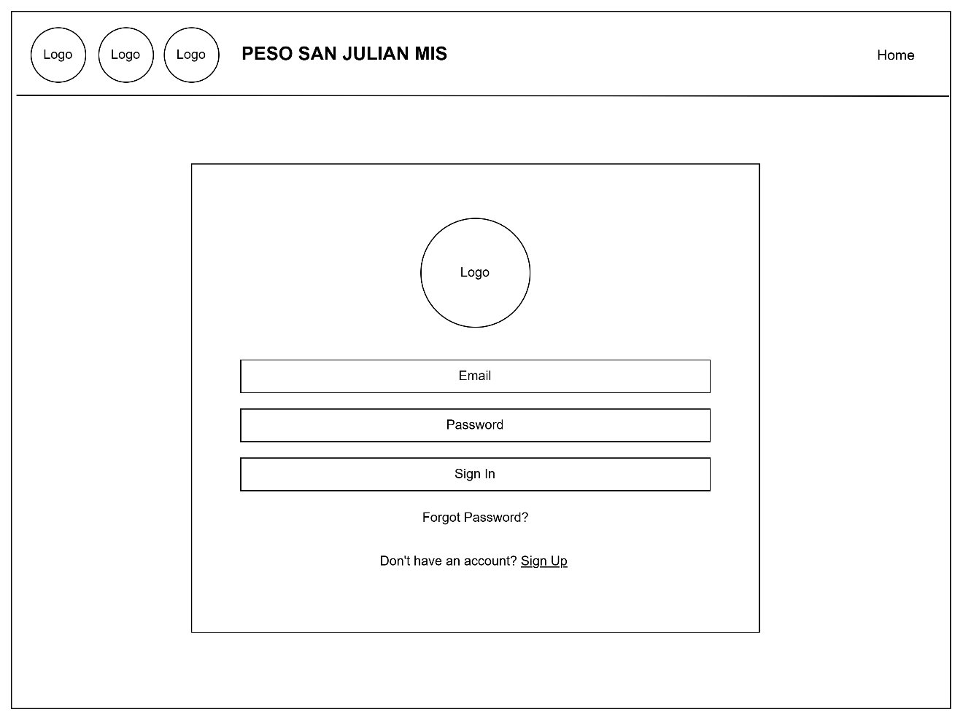

**Figure 6:** Sign in page

**Sign Up Page**

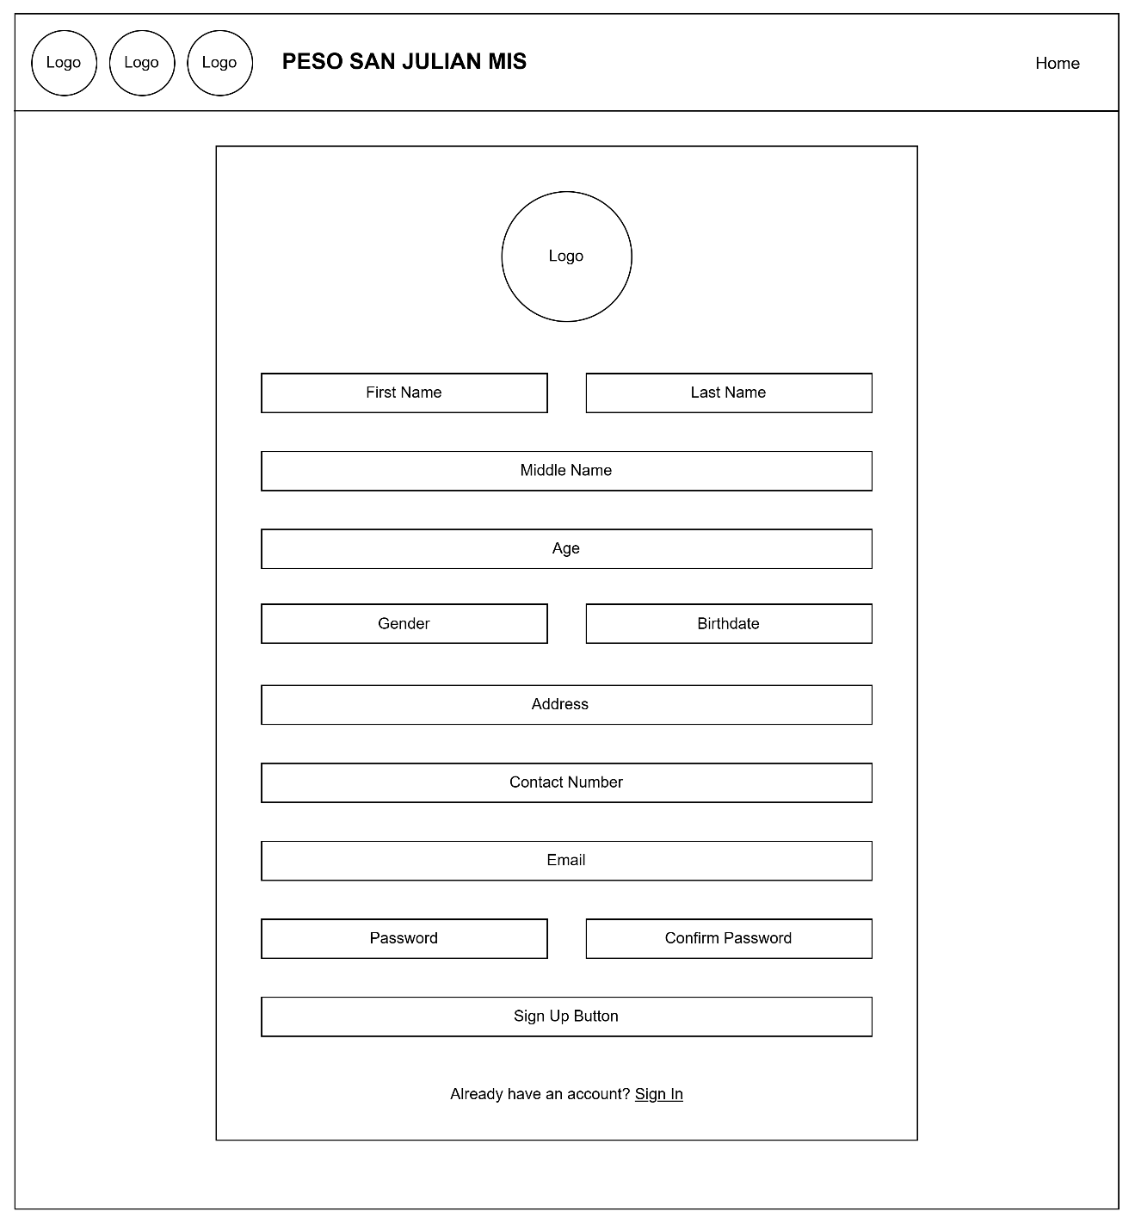

**Figure 7:** Sign up page

**Forgot Password Page**

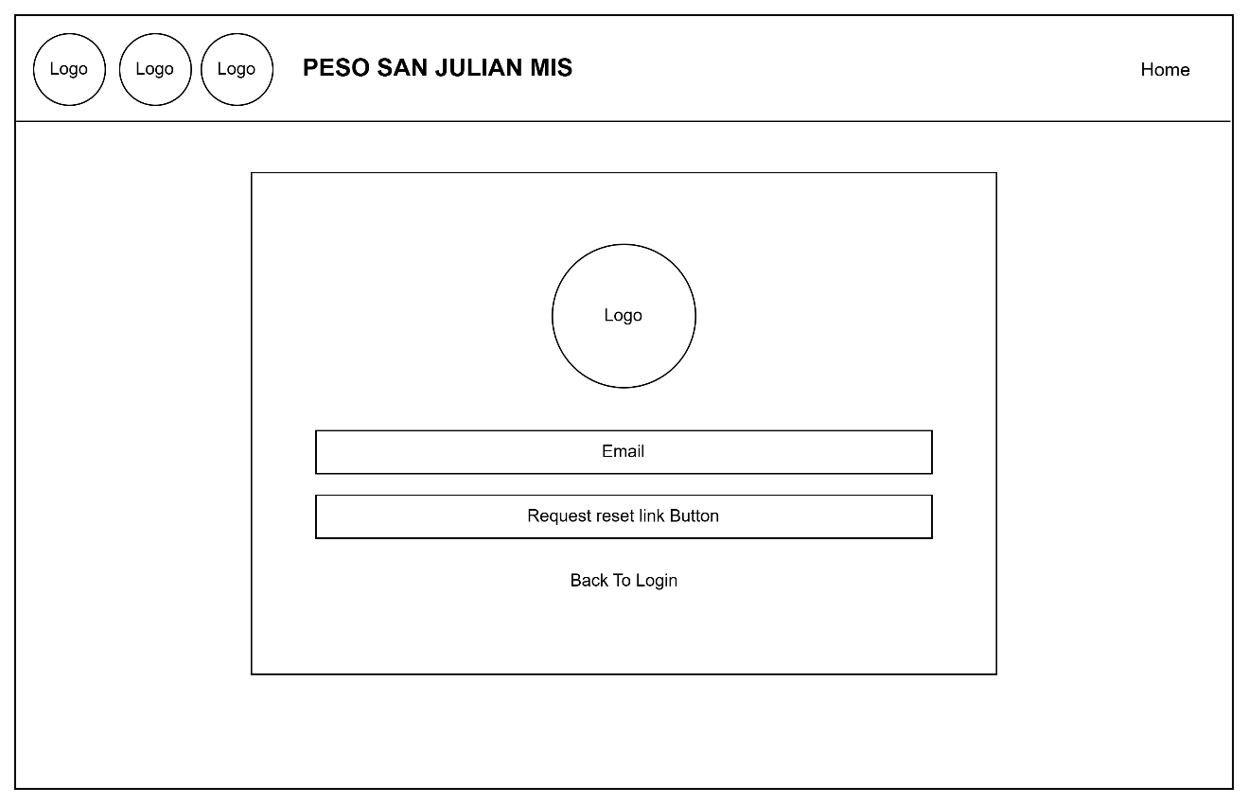

**Figure 8:** Forgot Password page

**Authentication Code Page**

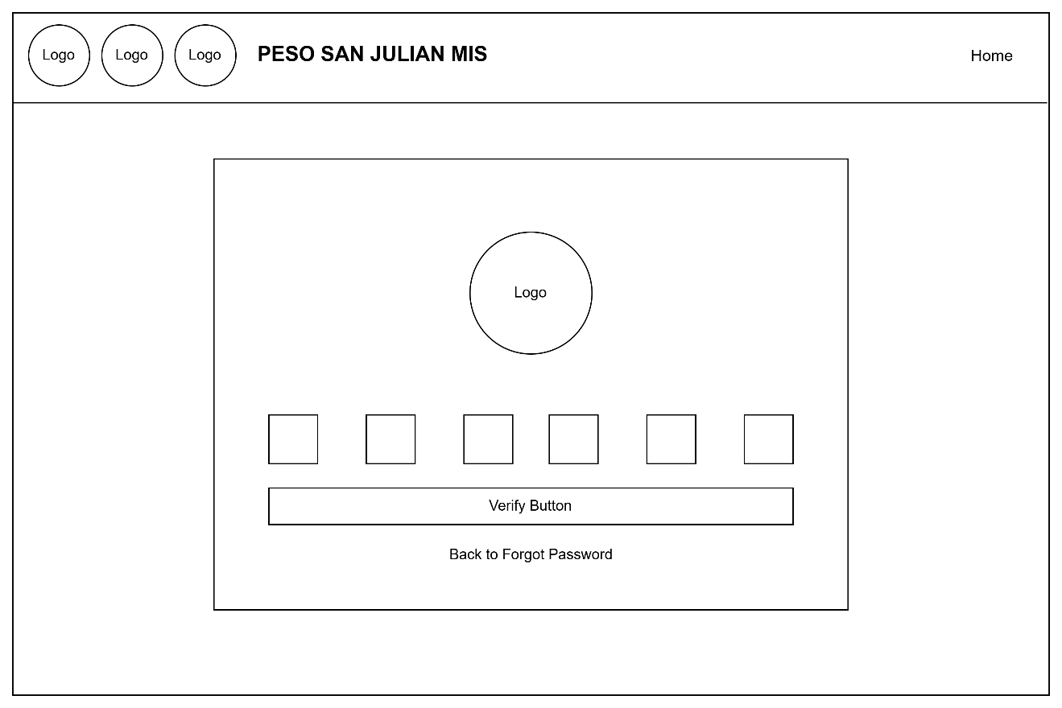

**Figure 9:** Authentication code page

**Reset Password Page**

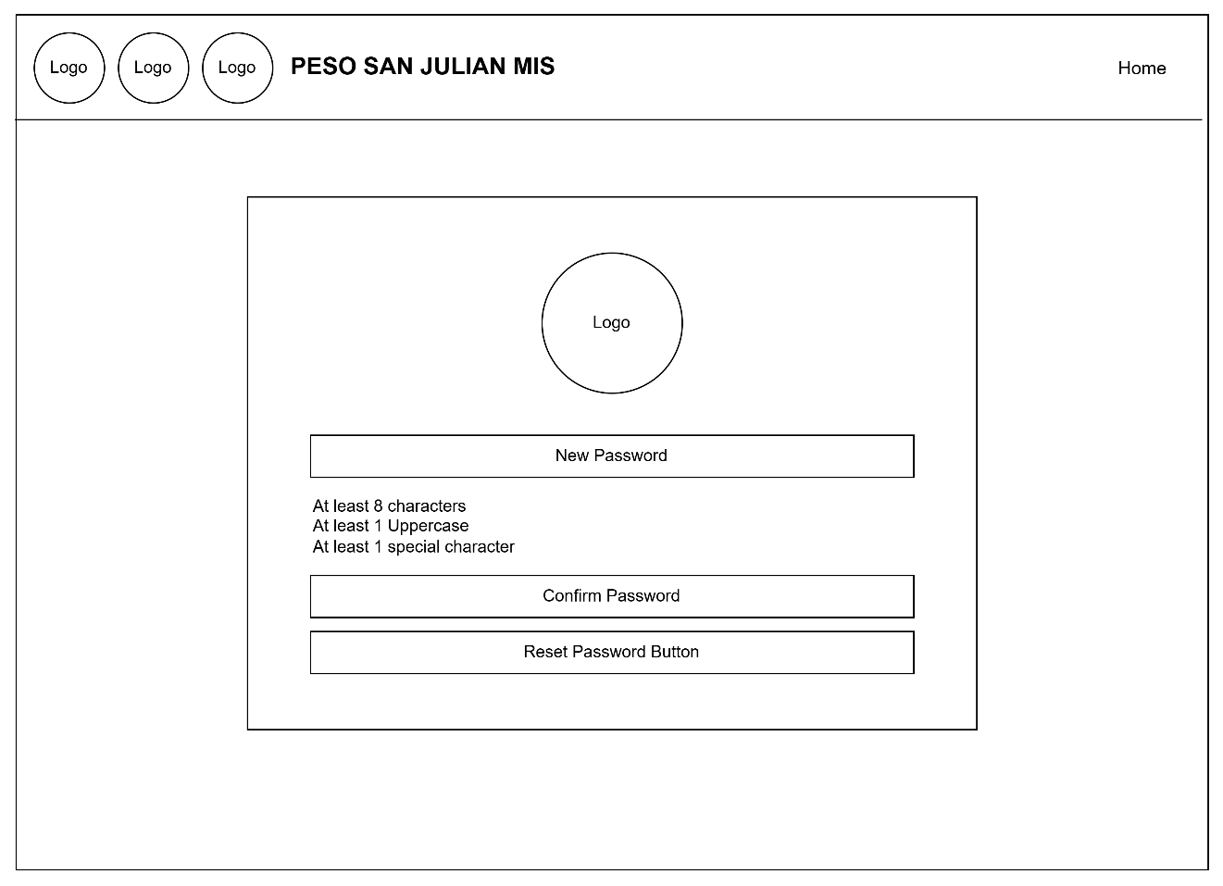

**Figure 10:** Reset password page

**User Dashboard Home Page**

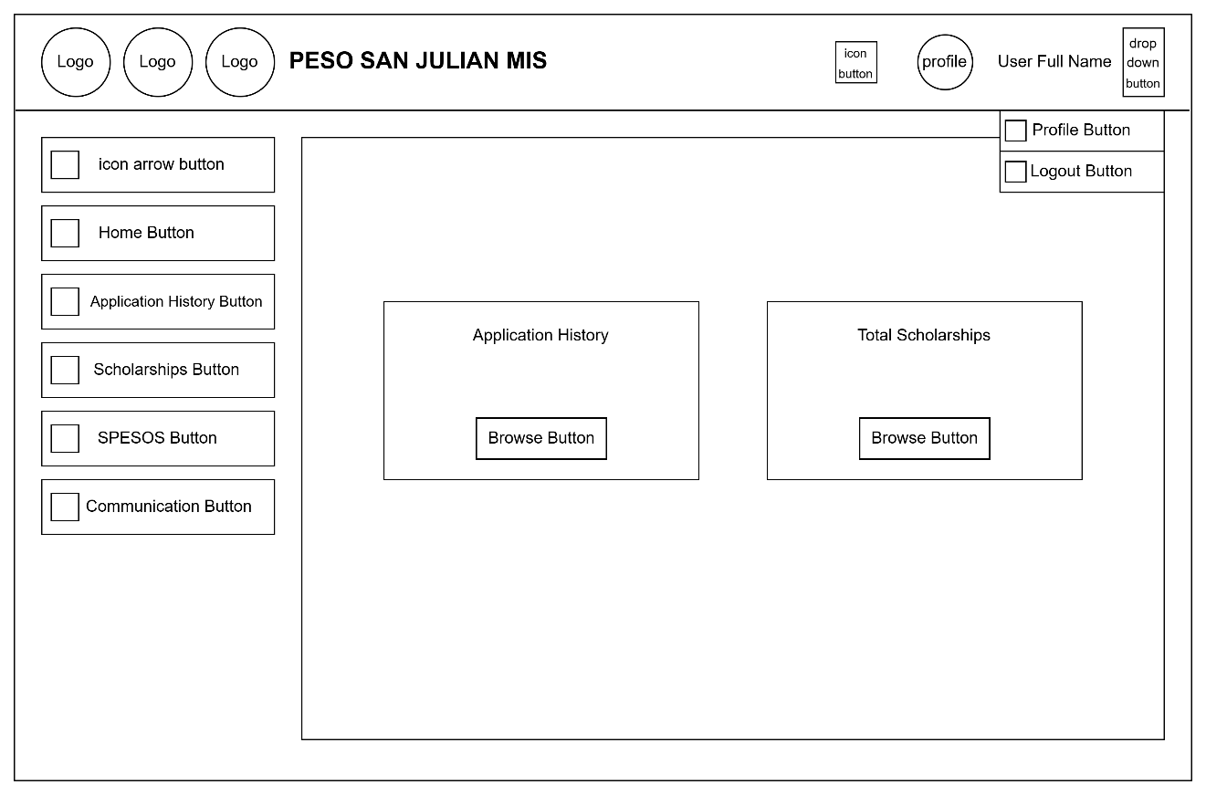

**Figure 11:** User dashboard homepage

**User Dashboard Home Page - Notification**

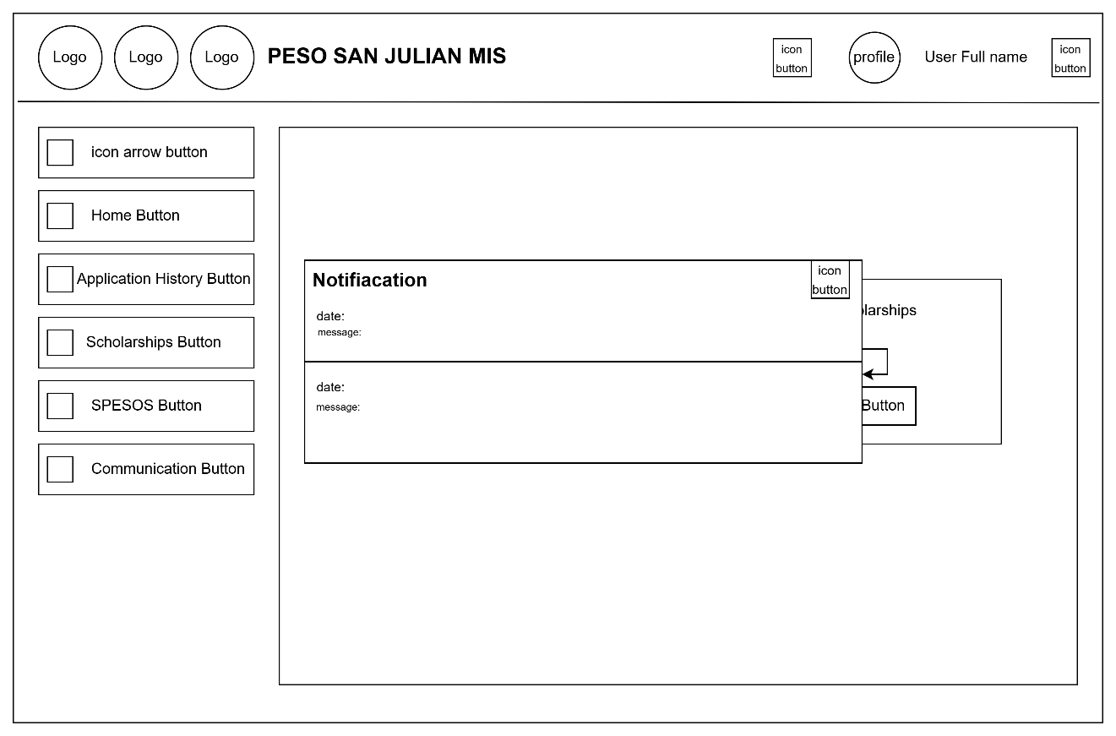

**Figure 12.:** User Dashboard Home Page – Notification

**User Dashboard Application History Page**

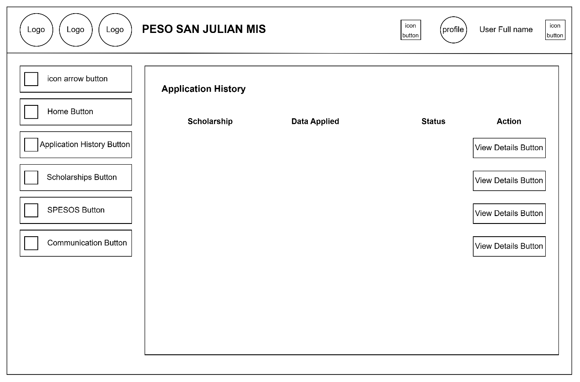

**Figure 13:** User dashboard application history page

**User Dashboard Scholarships Page**

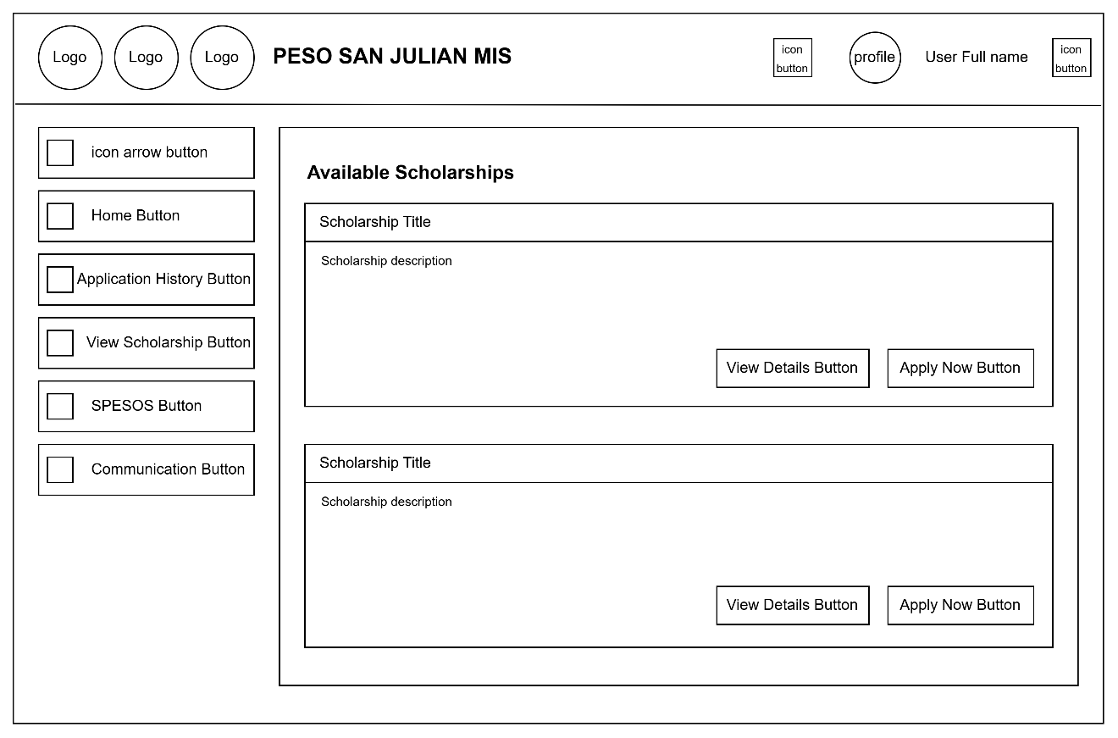

**Figure 14:** User dashboard view scholarship page

**User Dashboard Scholarships Page – View Details**

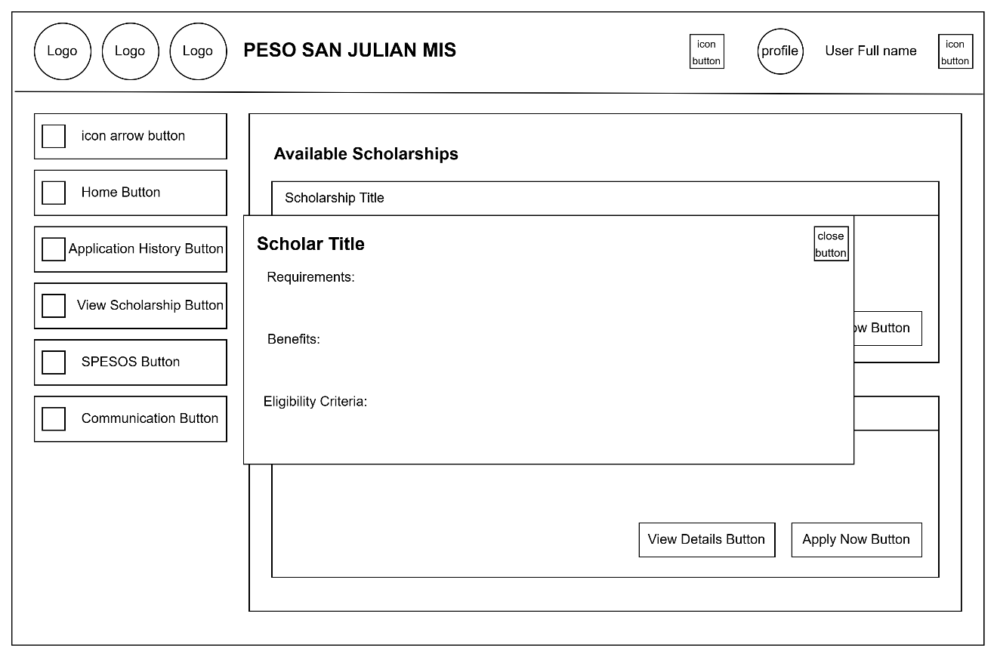

**Figure 15:** User dashboard view scholarship page – View details

**User Dashboard Scholarships Page – Apply Now**

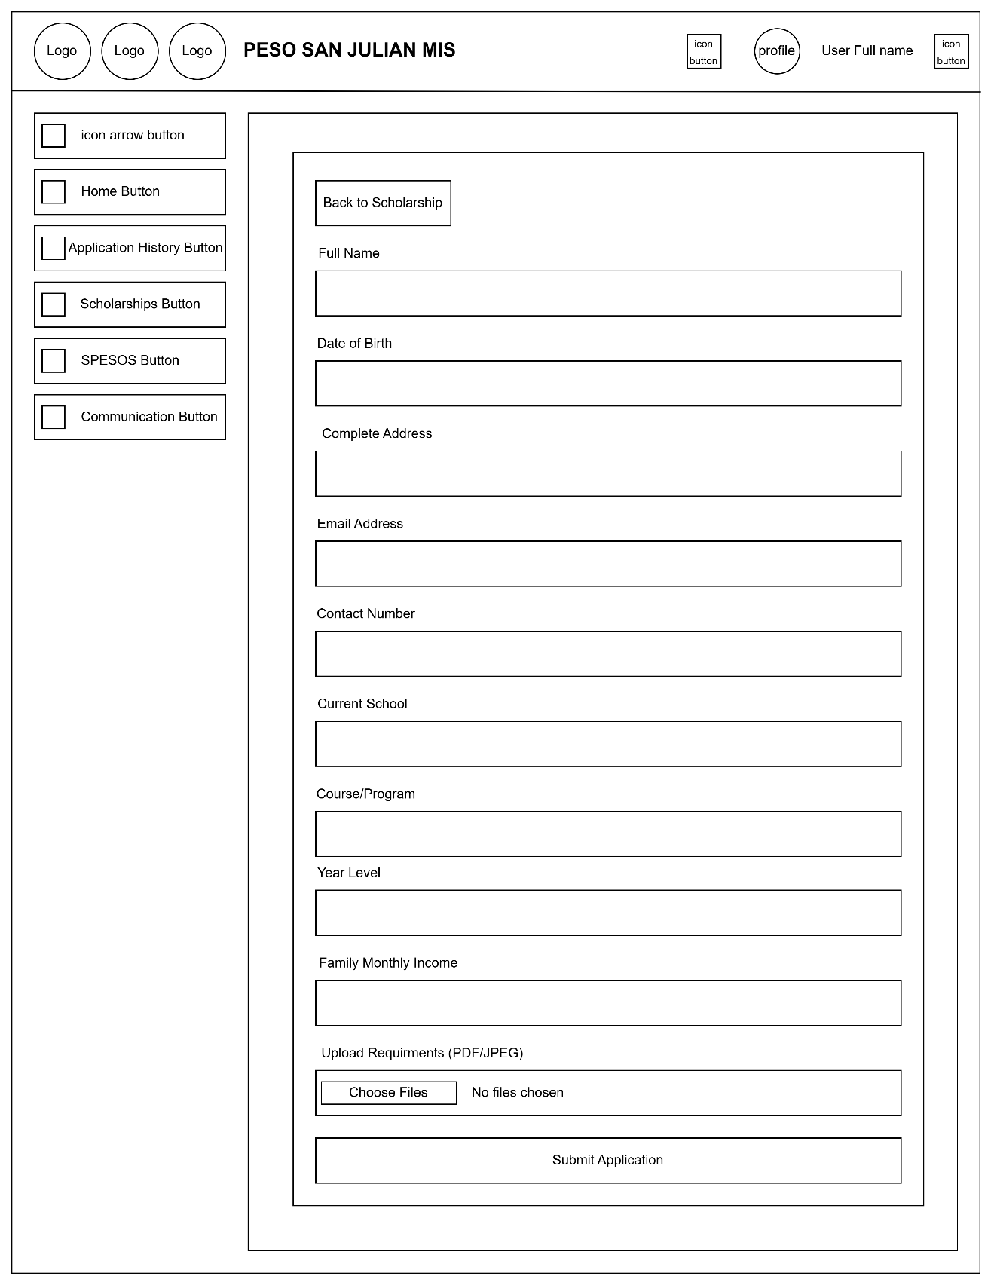

**Figure 16:** User dashboard view scholarship page – Apply Now

**User Dashboard SPESOS Page**

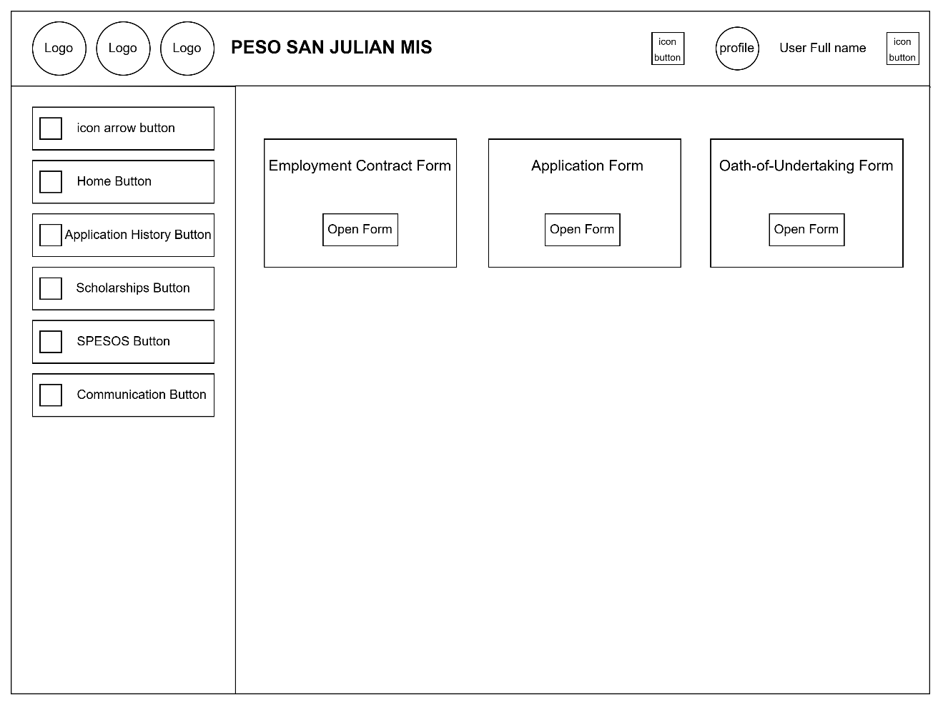

**Figure 17:** User dashboard spesos page

**User Dashboard SPESOS Page – Employment Contract Form**

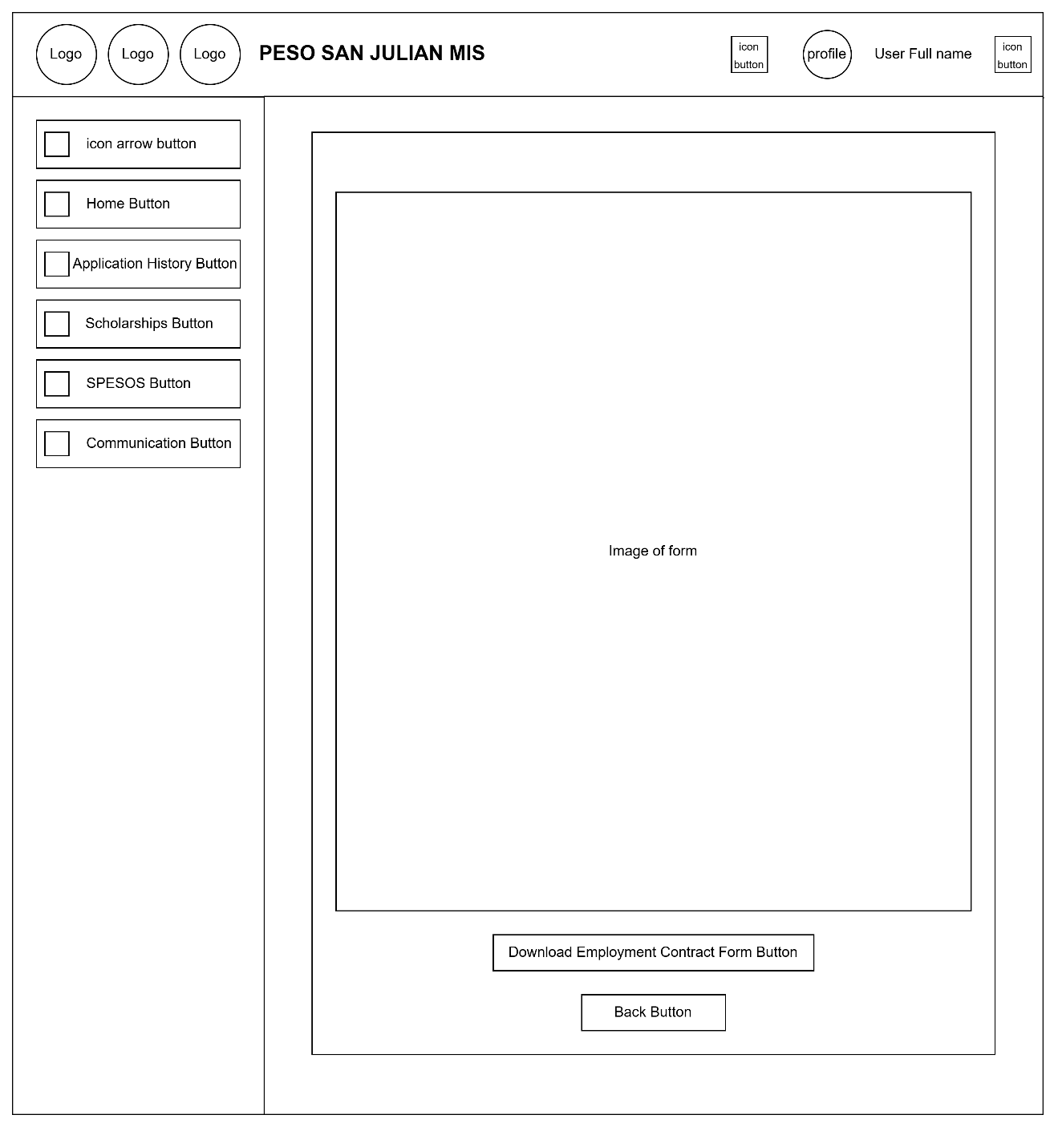

**Figure 18:** User dashboard spesos page – Employment contract form

**User Dashboard SPESOS Page – Application Form**

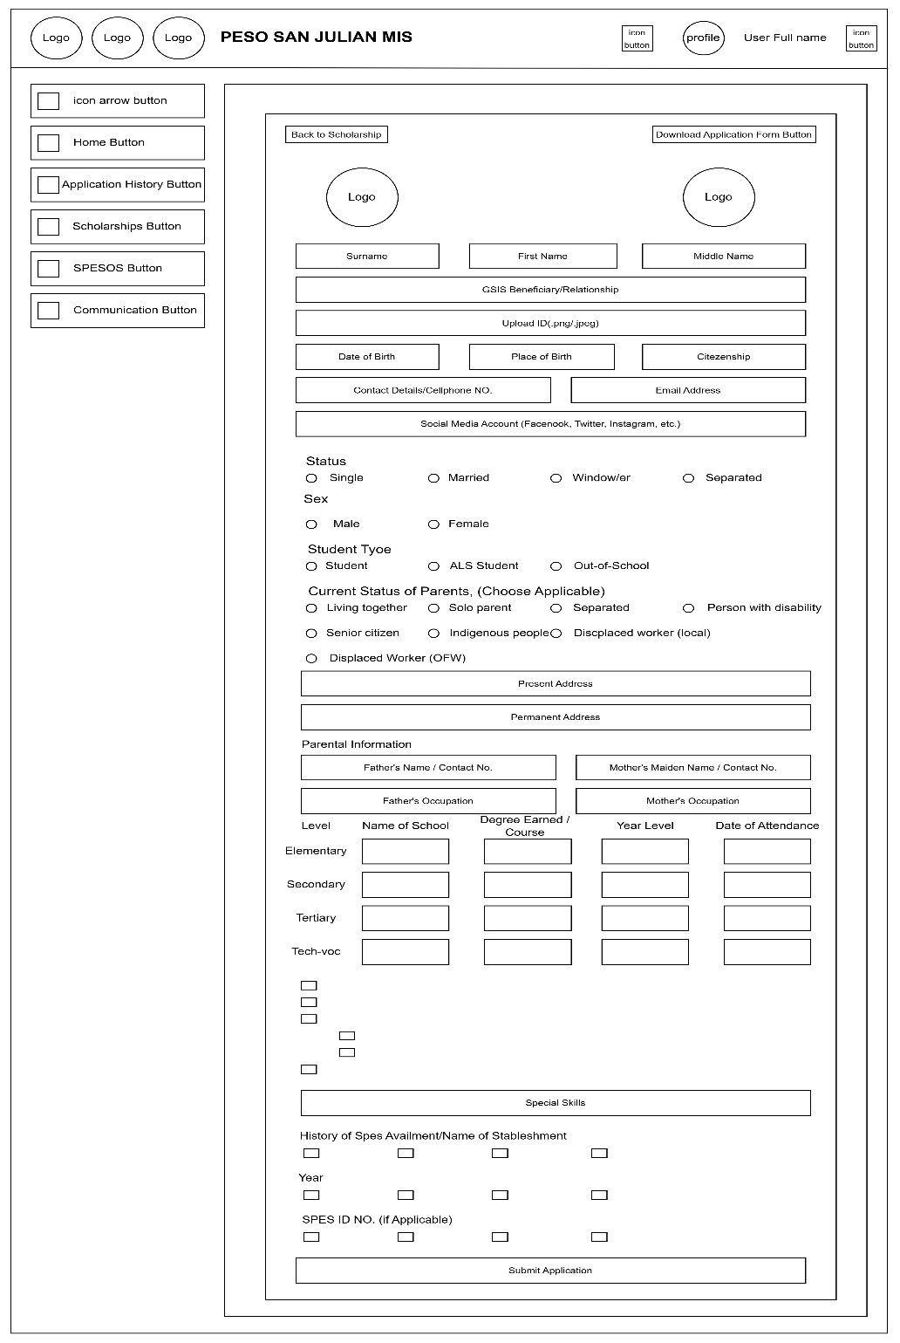

**Figure 19:** User dashboard peso page – Application form

**User Dashboard SPESOS Page – Oath-of-Undertaking Form**

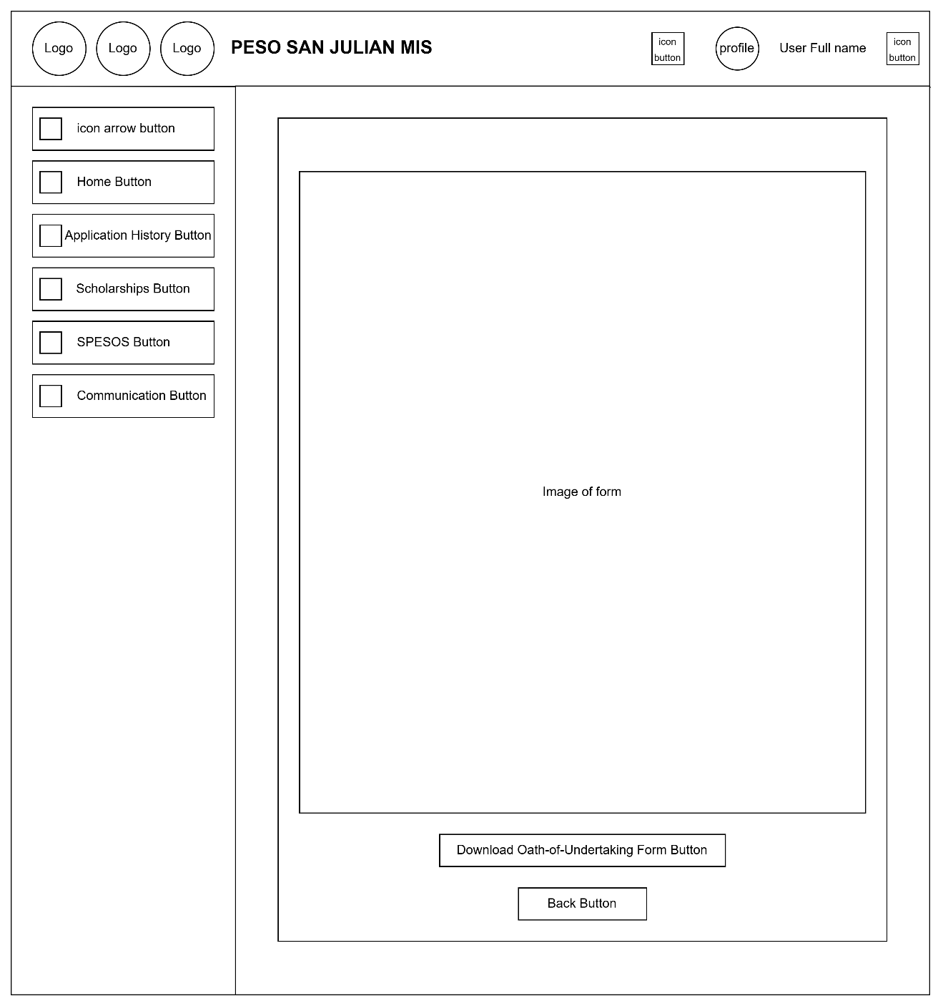

**Figure 20:** User dashboard spesos page – Oath-of-undertaking form

**User Dashboard Communication Page**

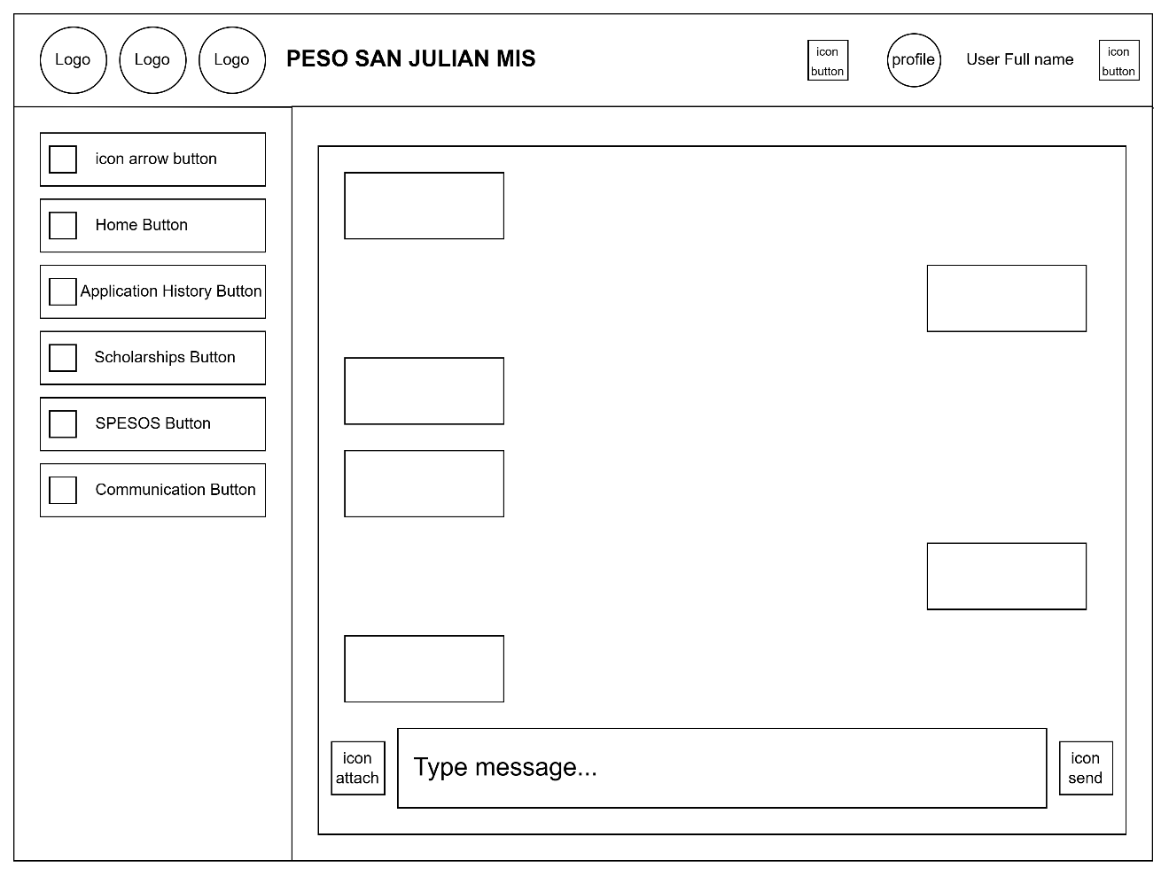

**Figure 21:** User dashboard communication page

**User Profile Page**

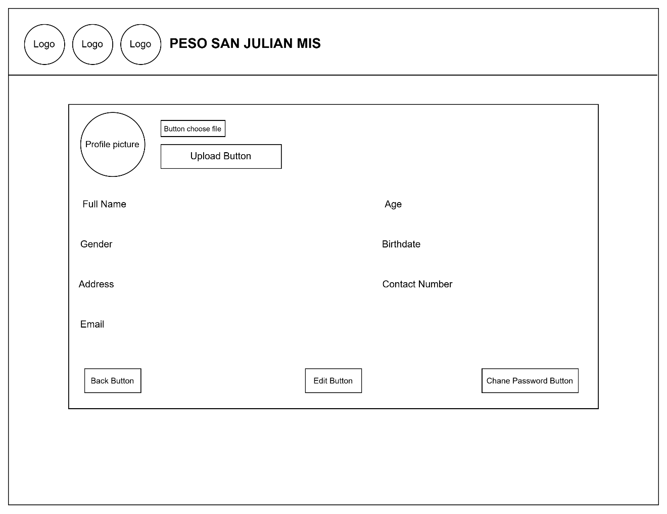

**Figure 21**: User profile page

**Edit Profile Page**

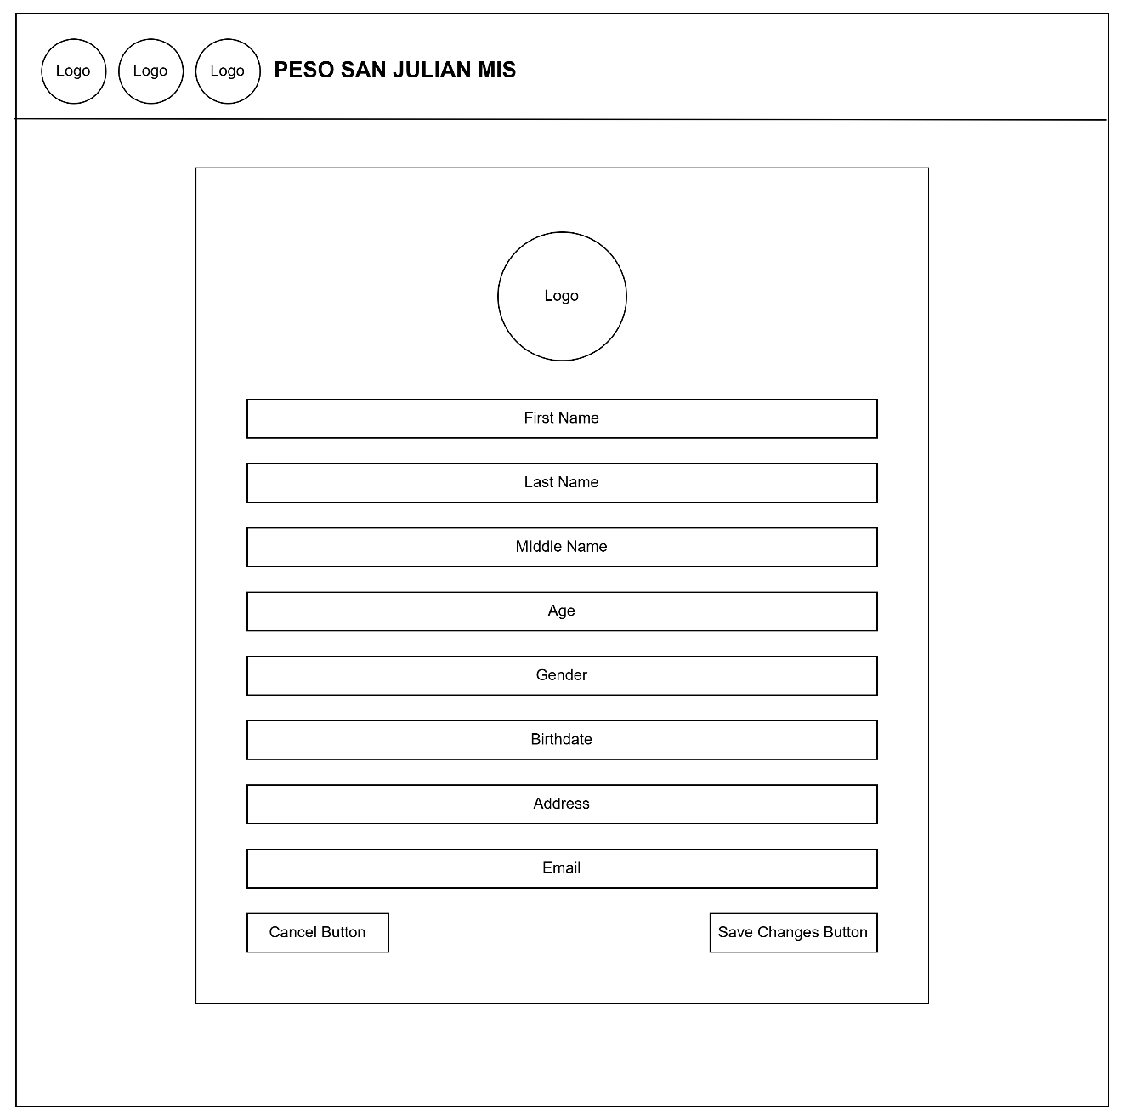

**Figure 22:** Edit user profile

**Change Password Page**

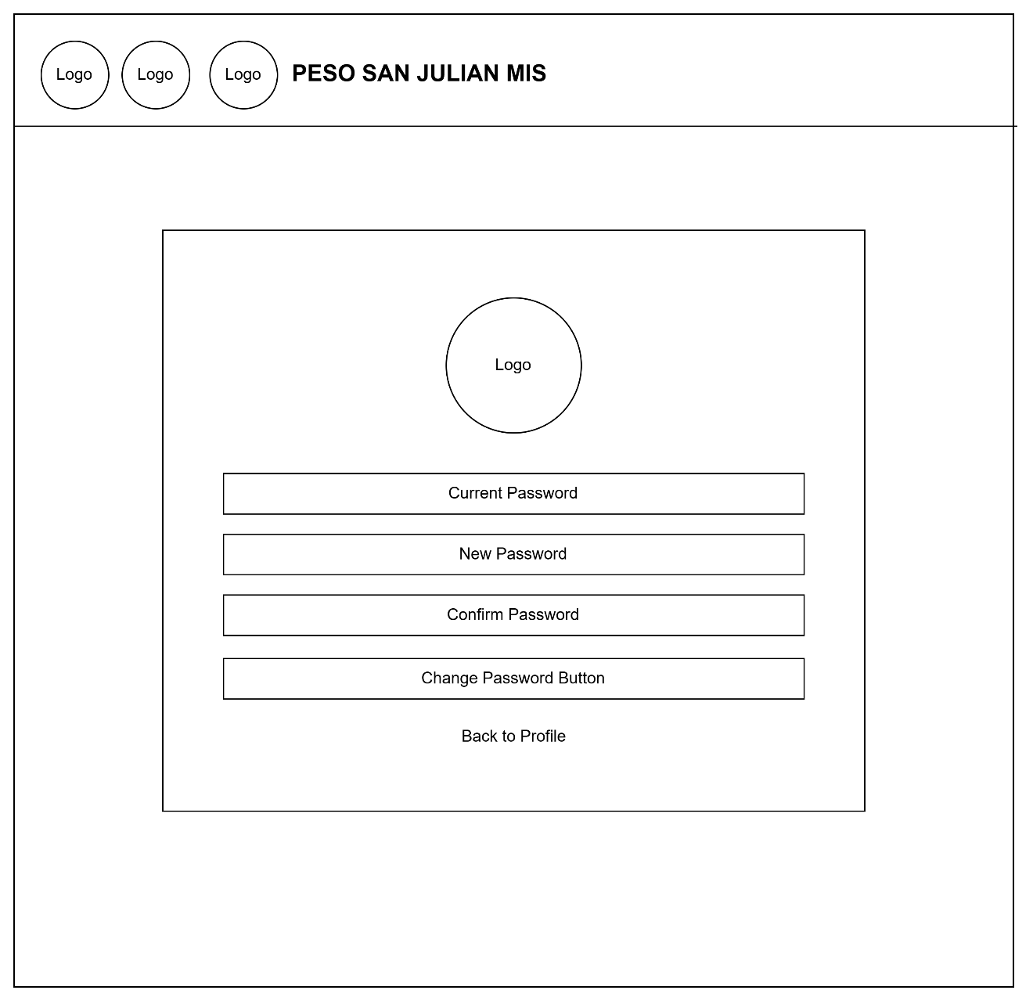

**Figure 23:** Change password page

**Admin Dashboard Home Page**

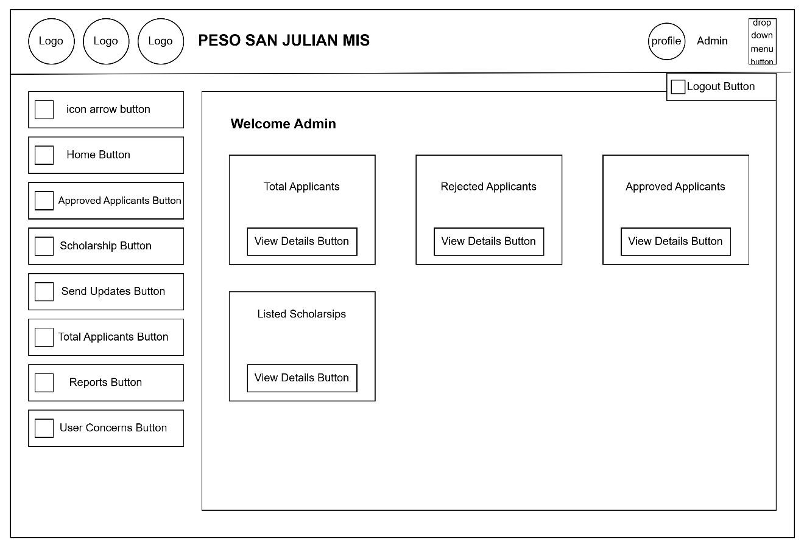

**Figure 24:** Admin dashboard Home page

**Admin Dashboard Approved Applicants Page**

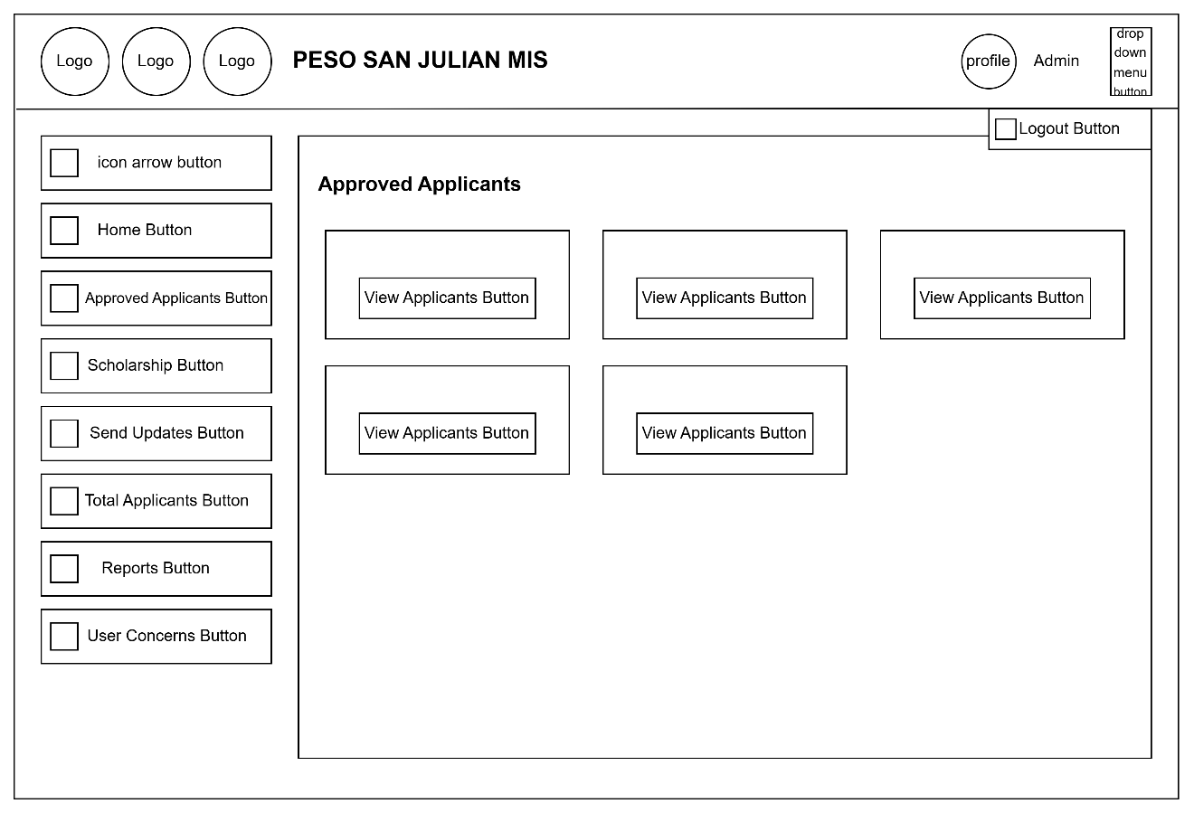

**Figure 25:** Admin dashboard approved applicant page

**Admin Dashboard Manage Scholarship Page**

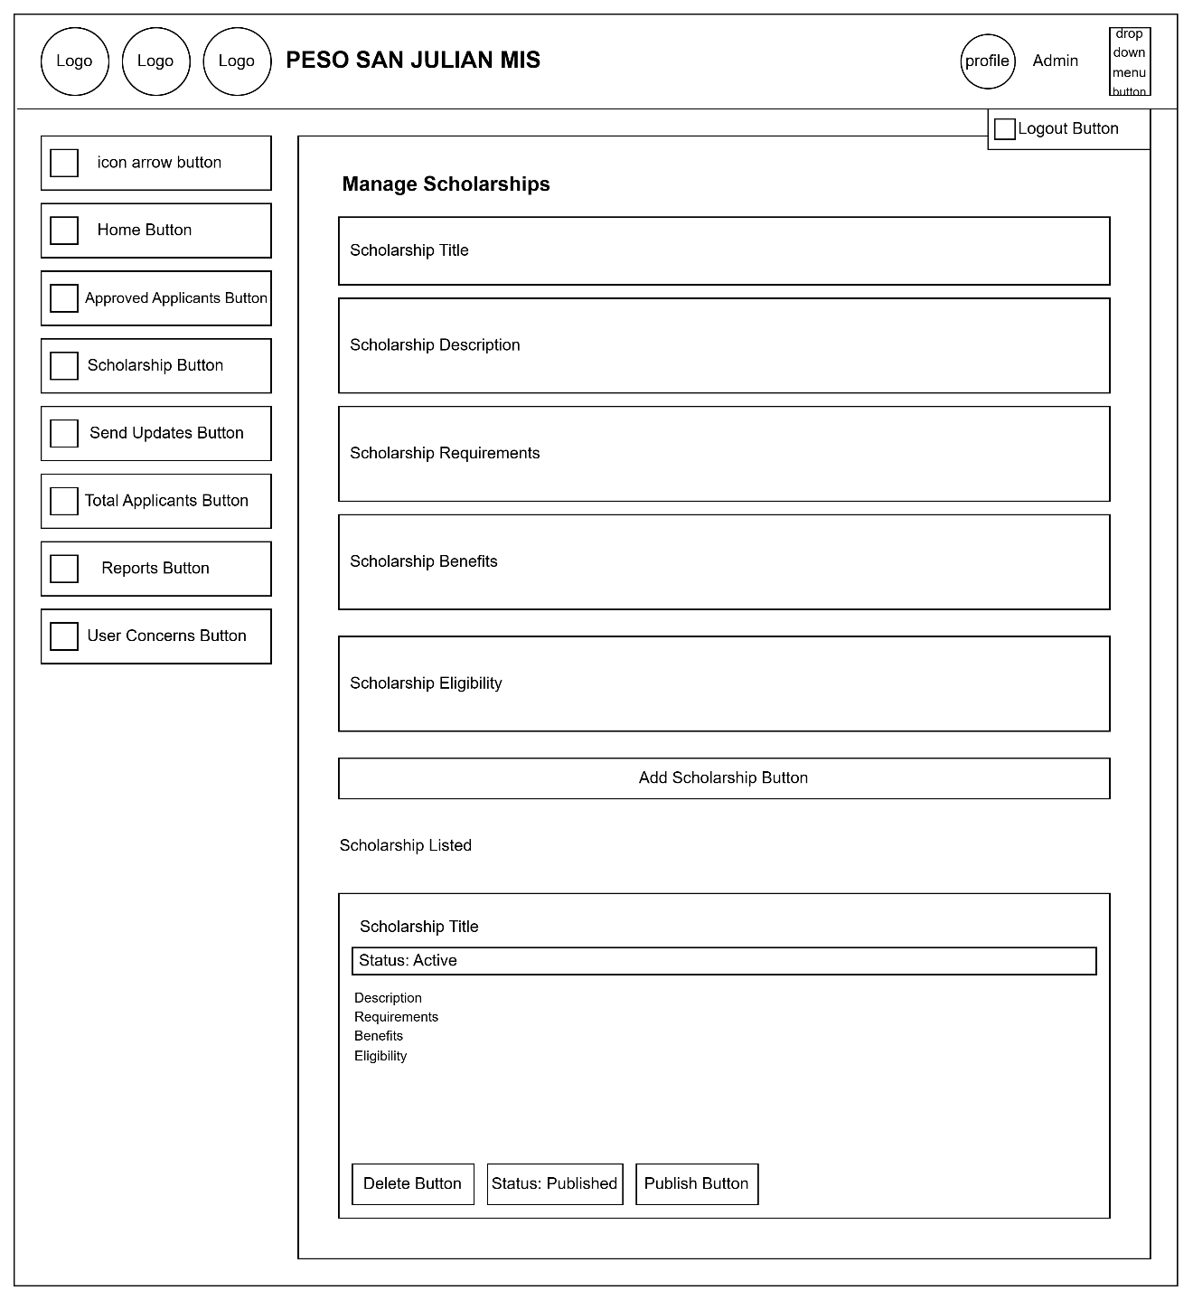

**Figure 26:** Admin dashboard manages scholarship page

**Admin Dashboard Send Updates Page**

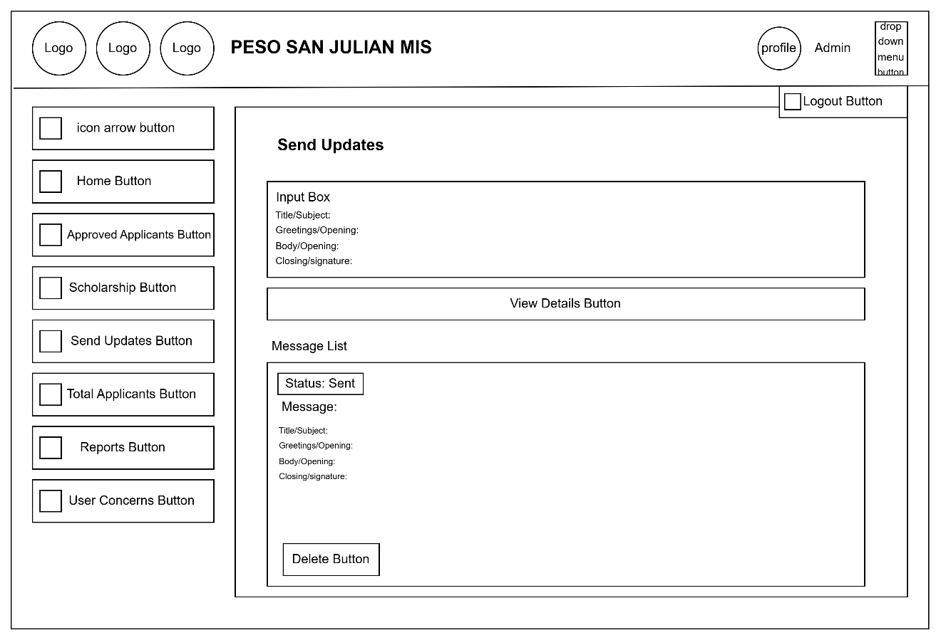

**Figure 27:** Admin dashboard sends updates page

**Admin Dashboard Total Applicants Page**

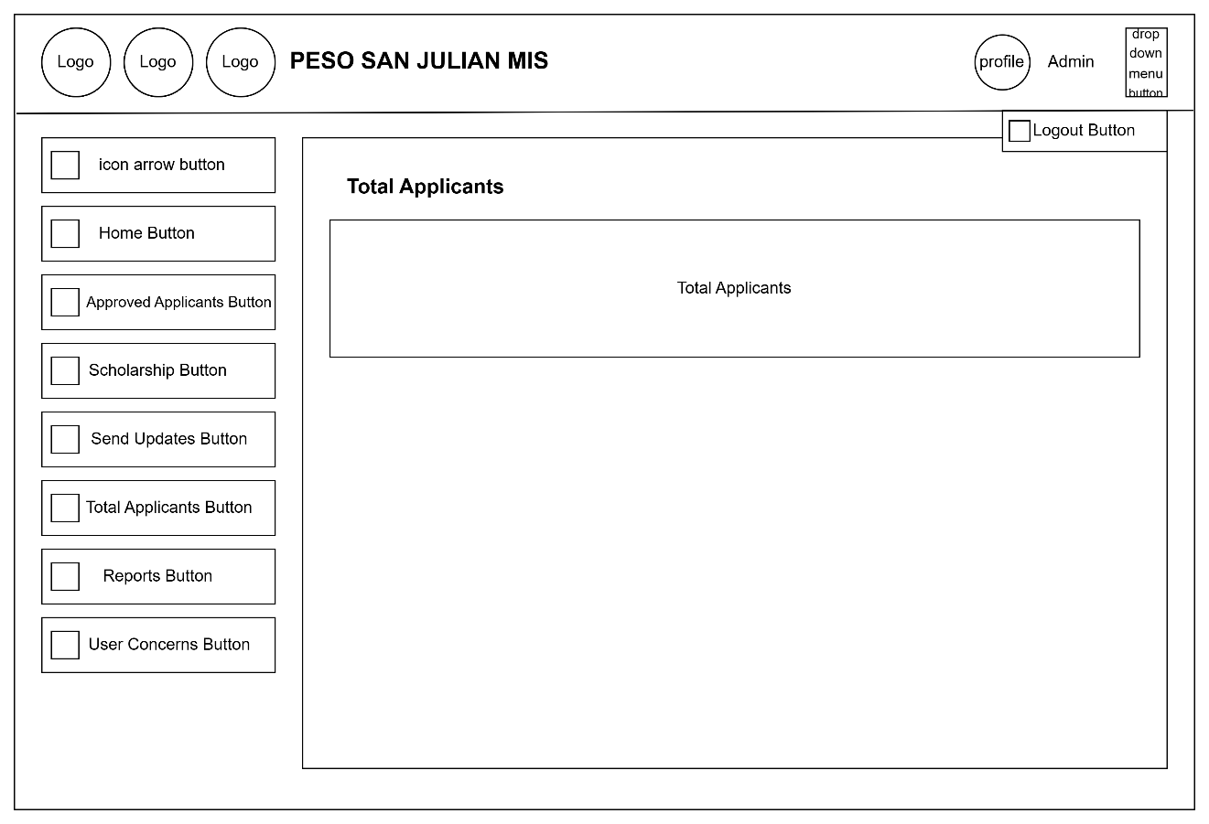

**Figure 28:** Admin dashboard total applicant page

**Admin Dashboard Reports Page**

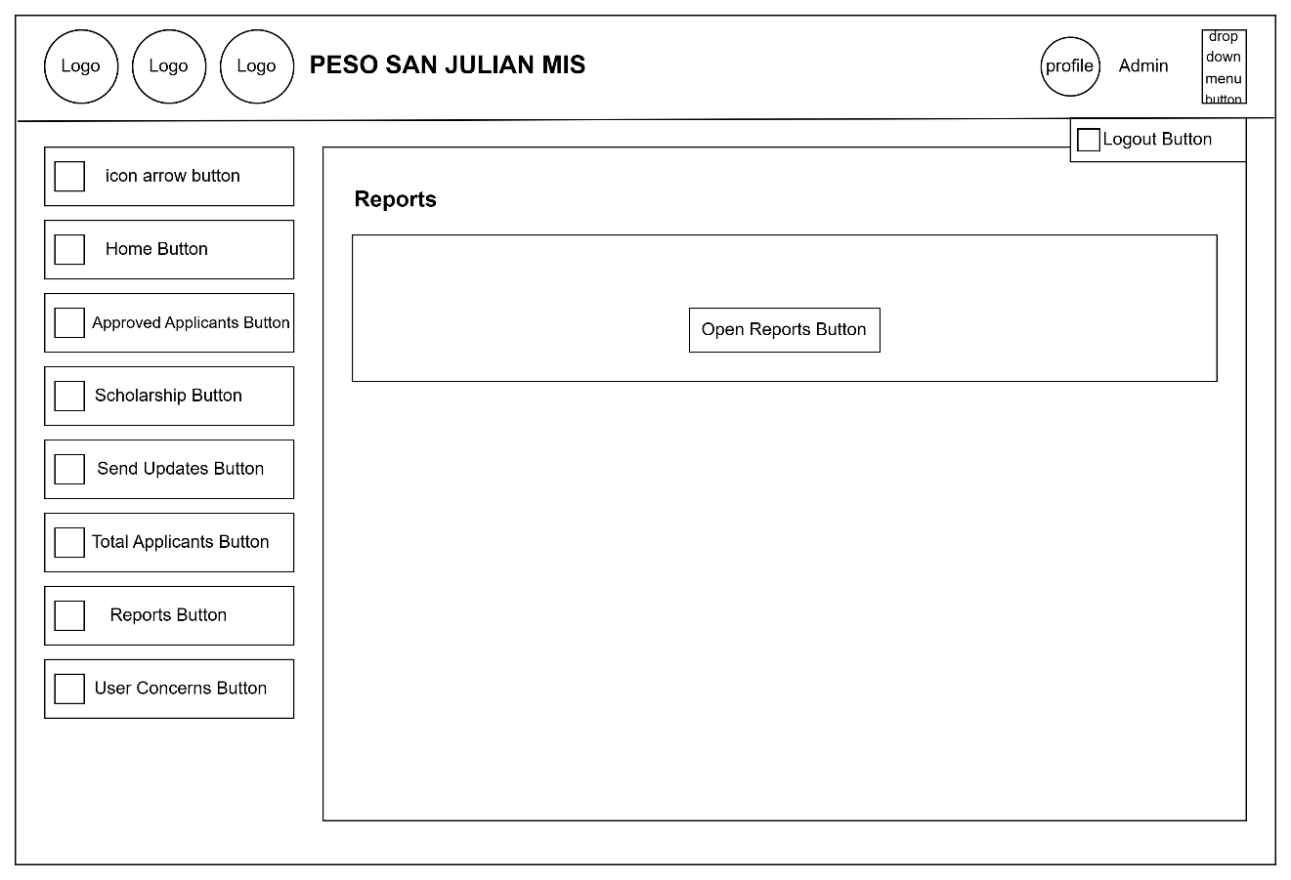

**Figure 29:** Admin dashboard reports page

**Admin Dashboard User Concerns Page**

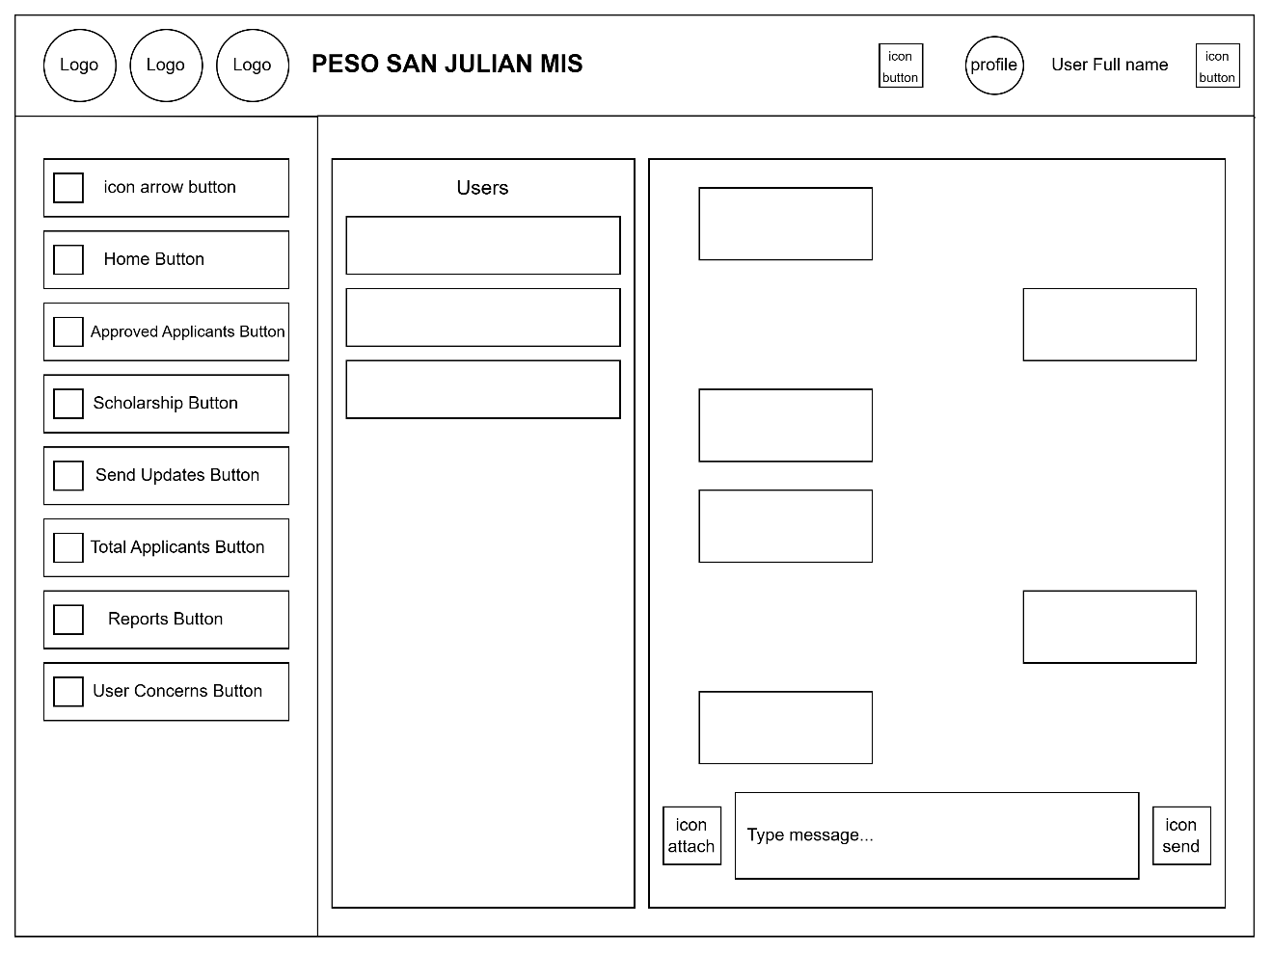

**Figure 30:** Admin dashboard reports page

**System Flowchart**

This portion discusses the system flow of the application, outlining its process and functionalities through the use of detailed system flowchart.

**Figure Definition**

Following are the symbols used in presenting processes in system flowchart. Each Symbol has a corresponding role used in developing and planning the systems flow to understand the system flowchart in developing the symbols with each description.

**Terminator**- Indicates the beginning or end of program flow in the diagram.

**Process**- Indicates any processing function.

**Decision**- Indicates a decision point between two or more paths in a flowchart.

**Data**- Can represent any type of data in a flowchart may it be an input or output data.

**Off-page Connector** - An off-page connector is used when the target is on another page.

**Off-page Connecter** - Are used to replace long lines on a flow chart page.

**Database**- Represent data housed on a storage service.

**System Flowchart**

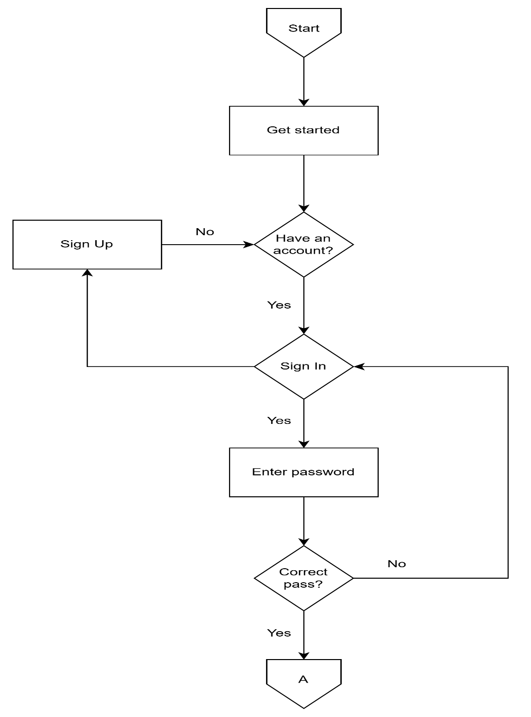

**Figure 24:** System Flowchart

**Flowchart:** Signup

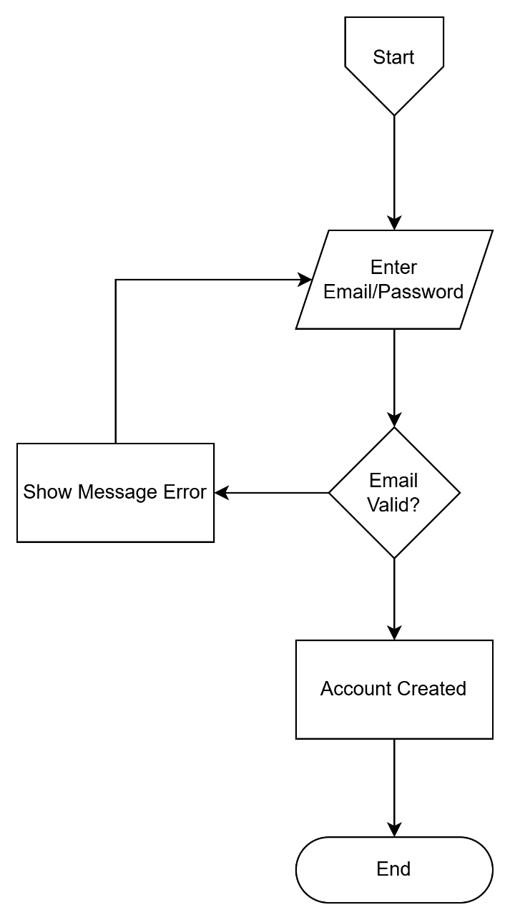

**Figure 25:** Sign up

**Flowchart:** User homepage

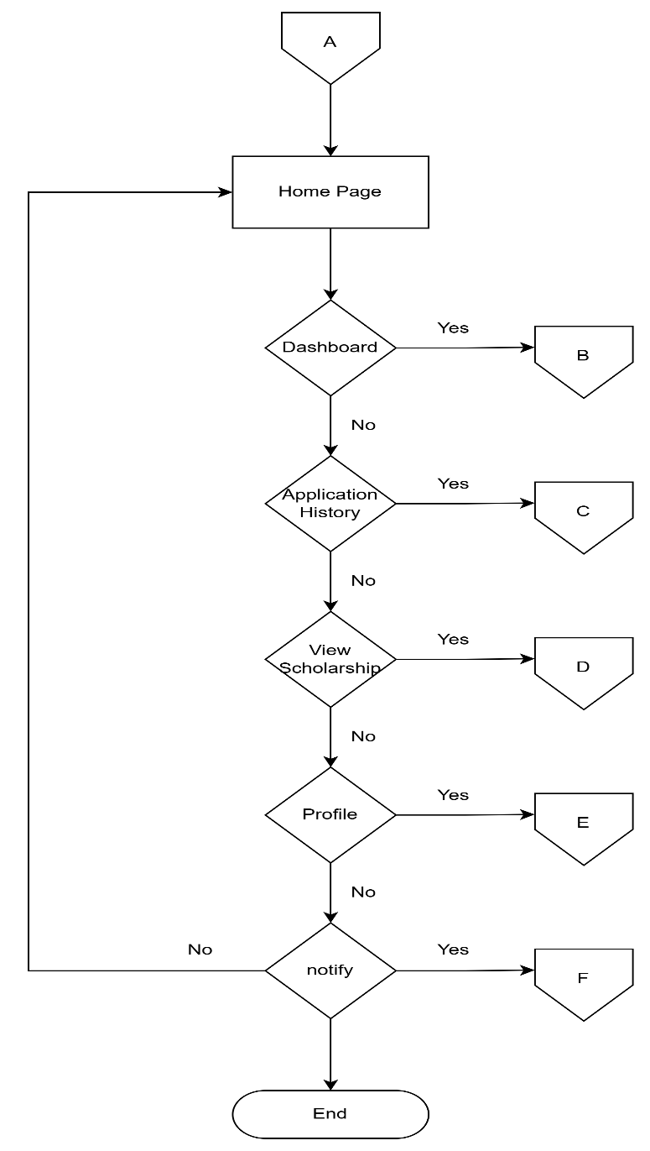

**Figure 26:** User homepage

**Flowchart:** User dashboard

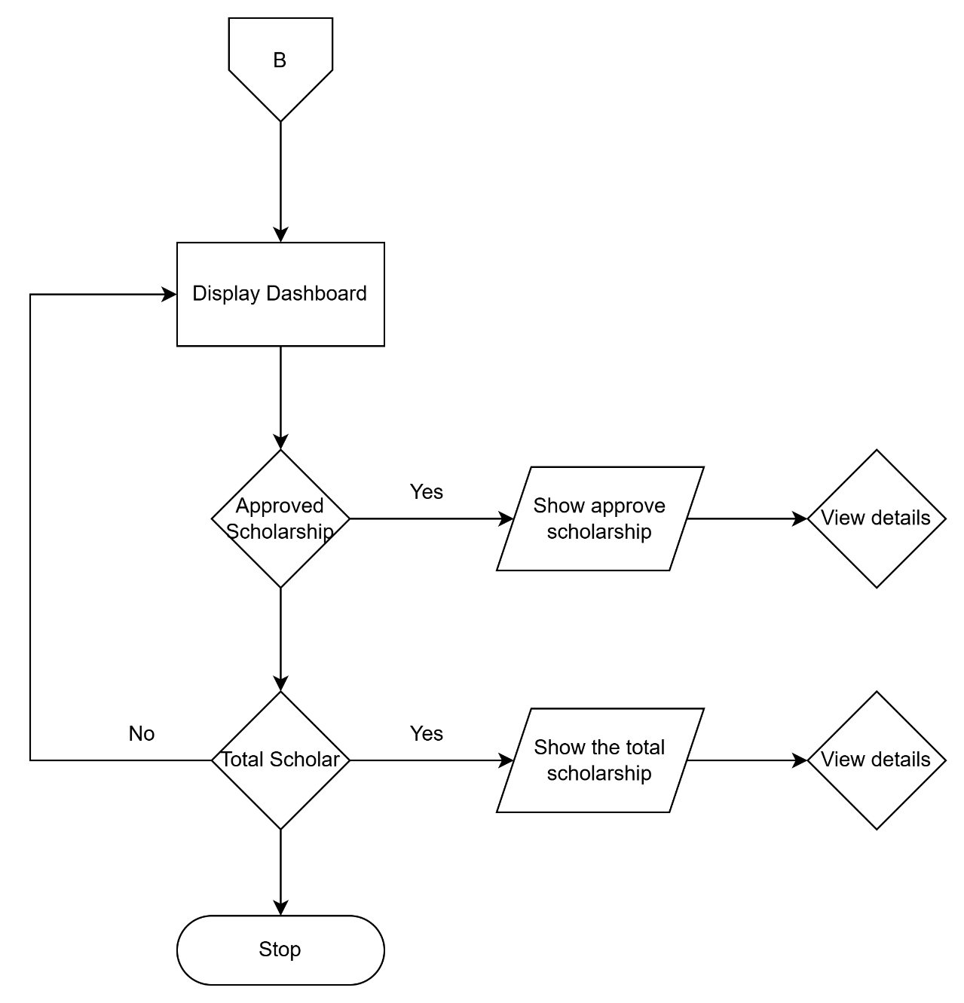

**Figure 27:** User dashboard

**Flowchart:** Application history

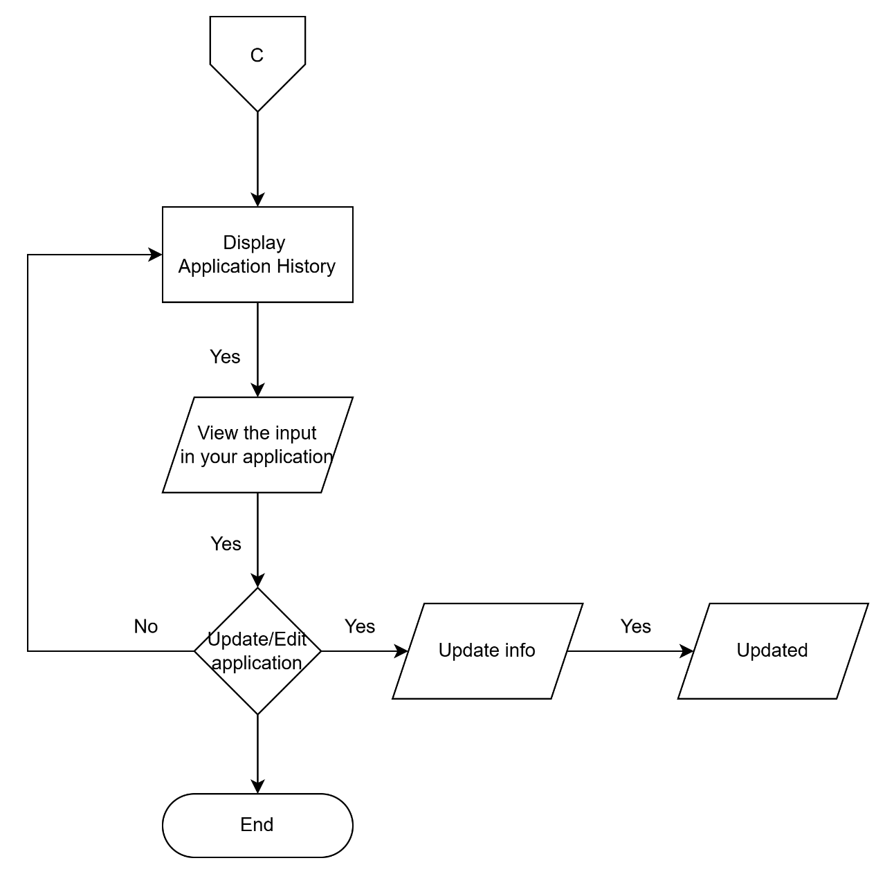

**Figure 28:** Application history

**Flowchart:** Total scholarship

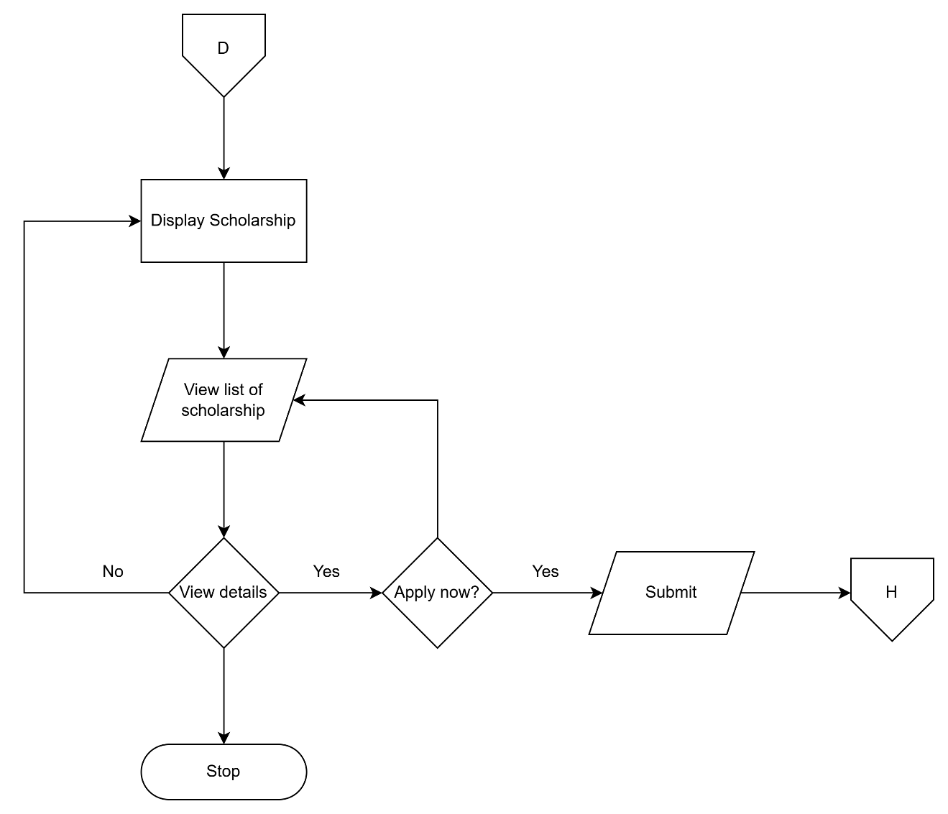

**Figure 29:** Total scholarship

**Flowchart:** Profile

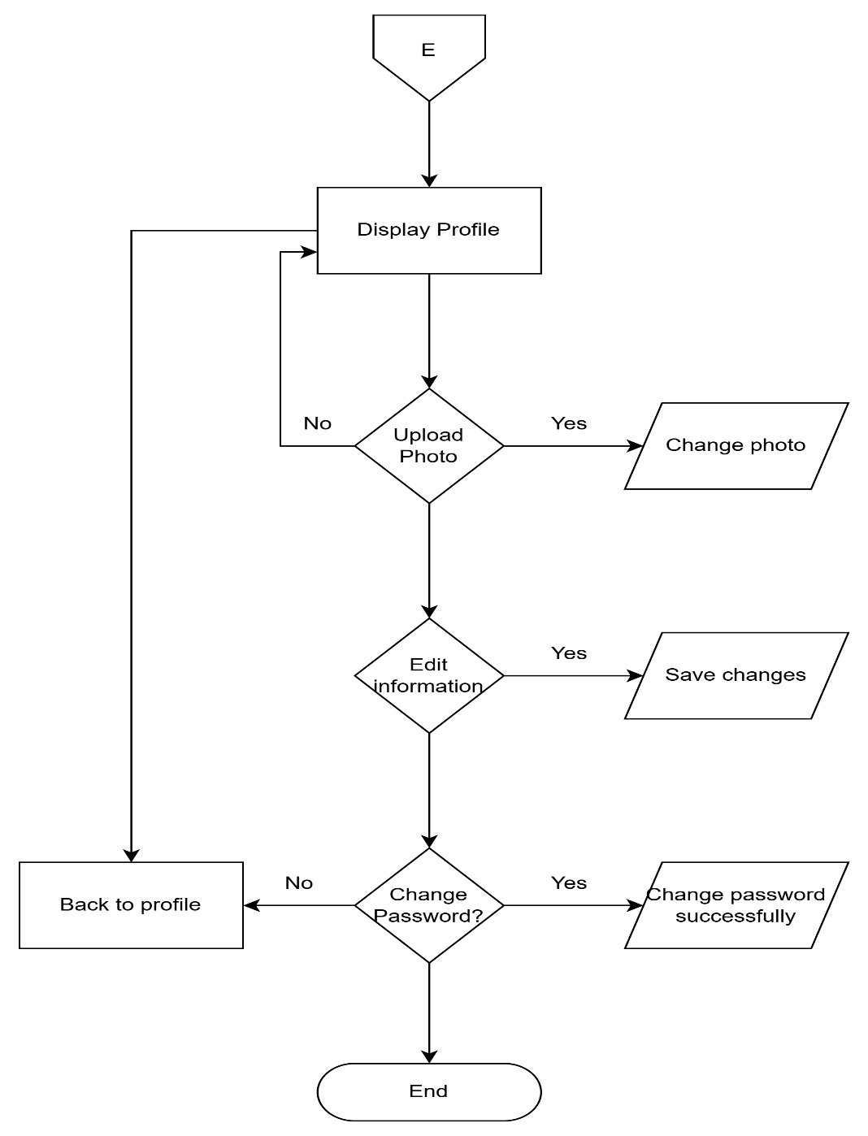

**Figure 30:** Profile

**Flowchart:** Notification

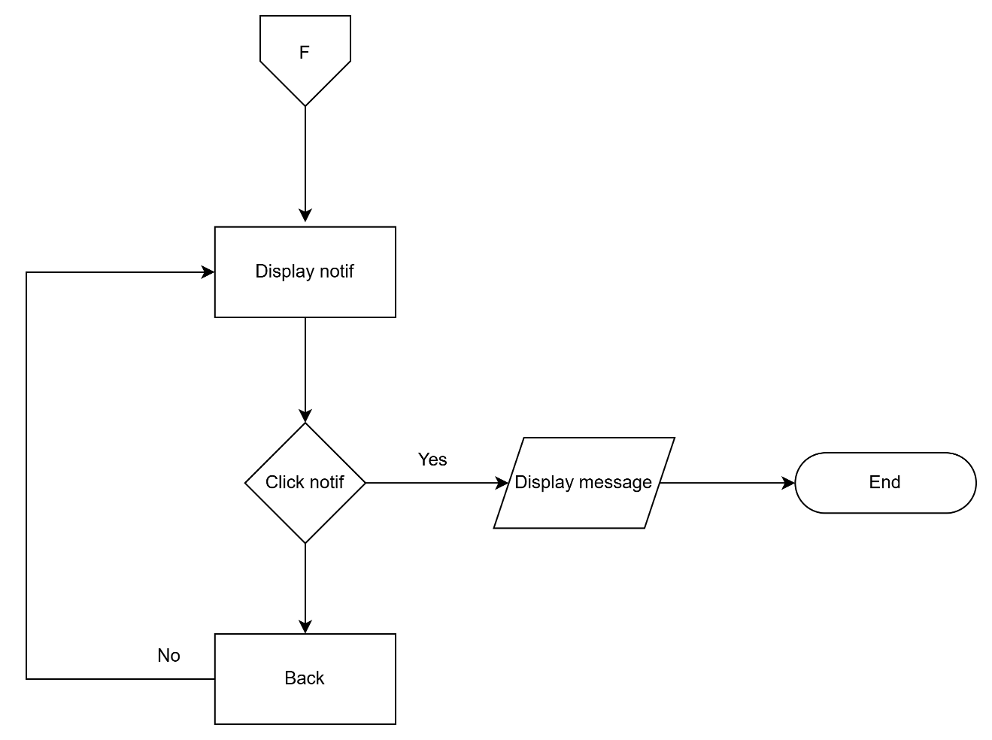

**Figure 31:** Notification

**Flowchart:** Admin

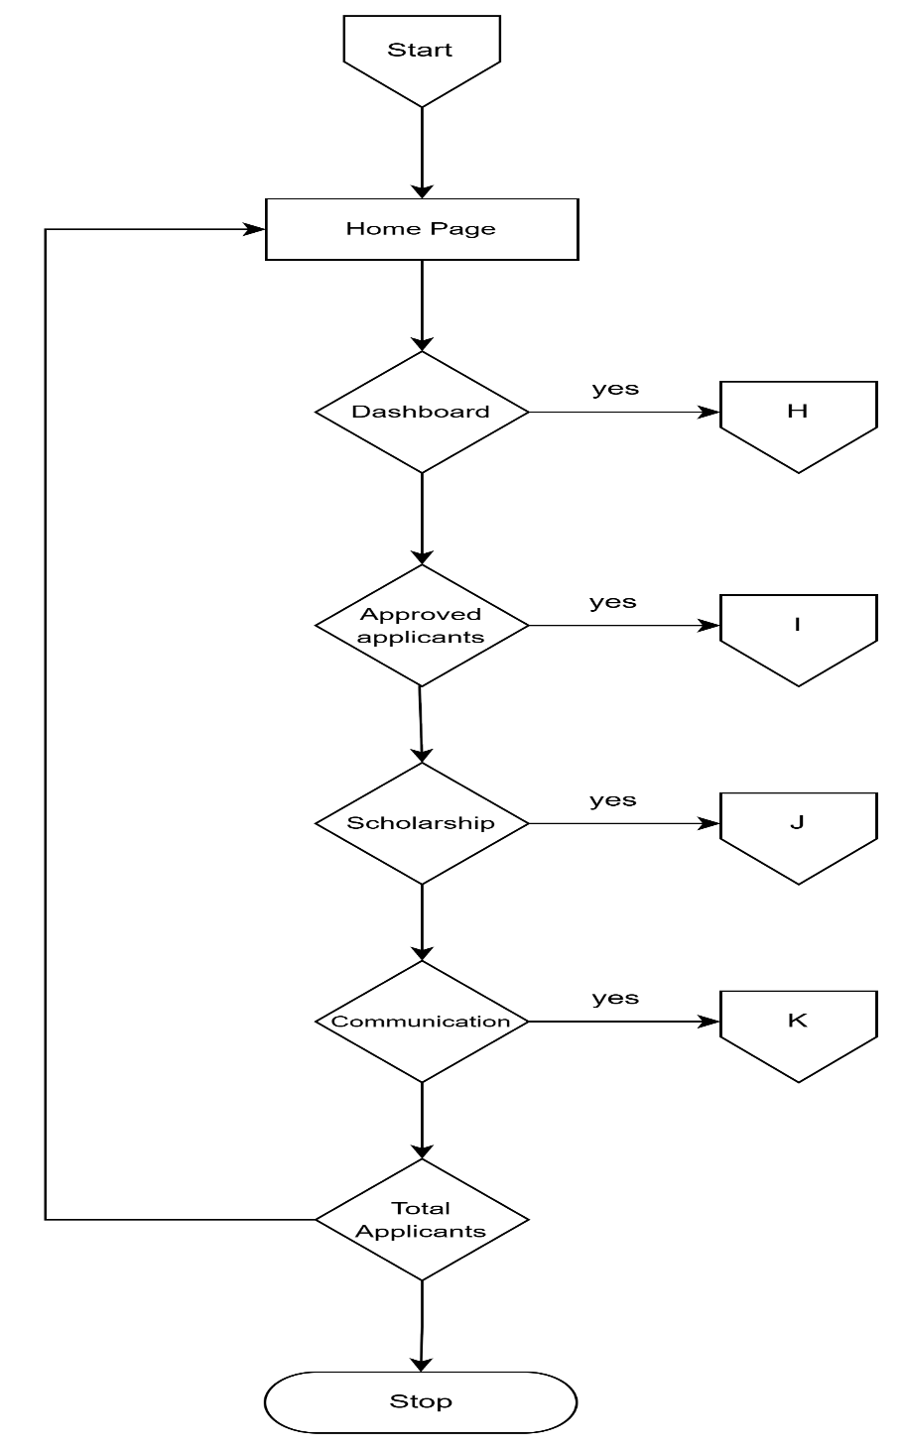

**Figure 32:** Admin homepage

**Flowchart:** Admin dashboard

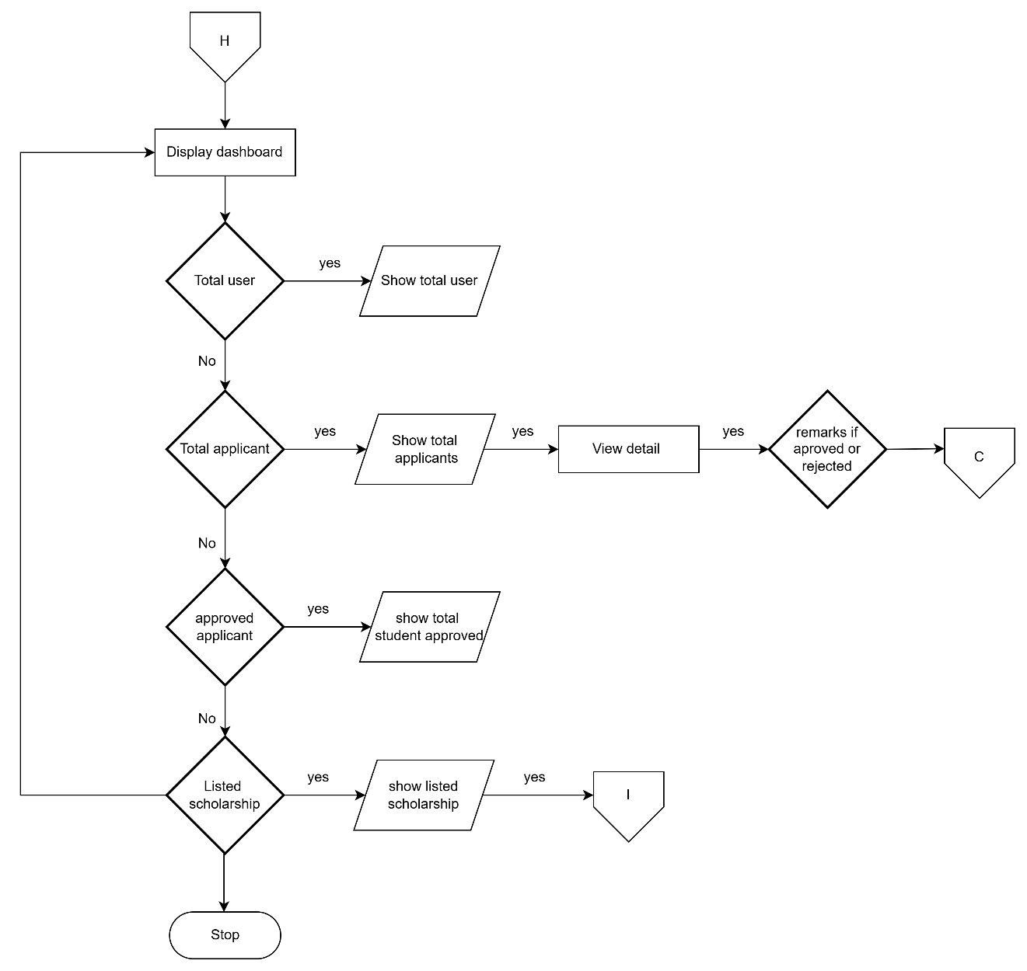

**Figure 33:** Admin dashboard

**Flowchart:** View applicant

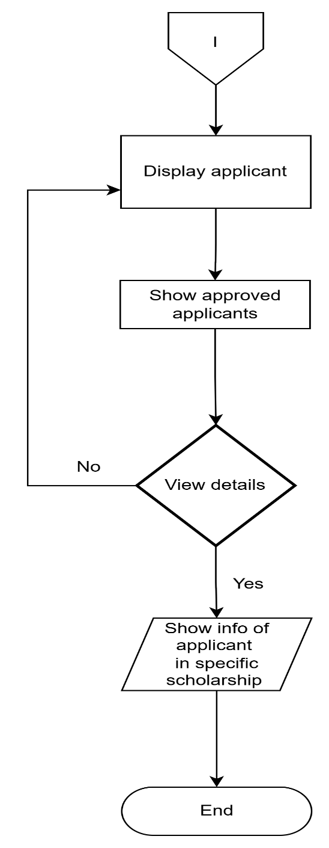

**Figure 34:** View applicant

**Flowchart:** Scholarship

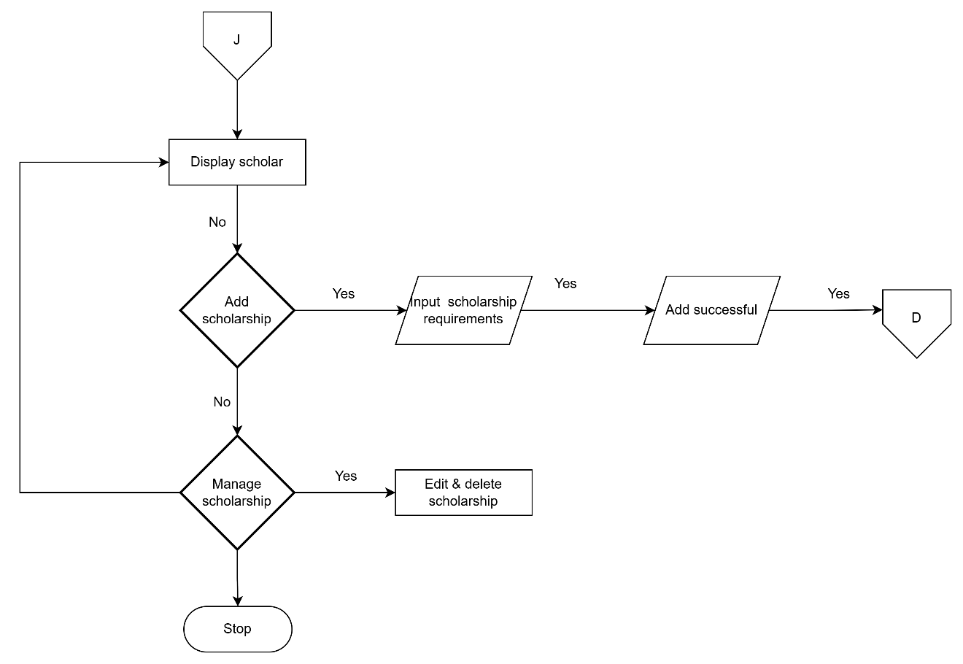

**Figure 35:** scholarship

**Flowchart:** Communication/message

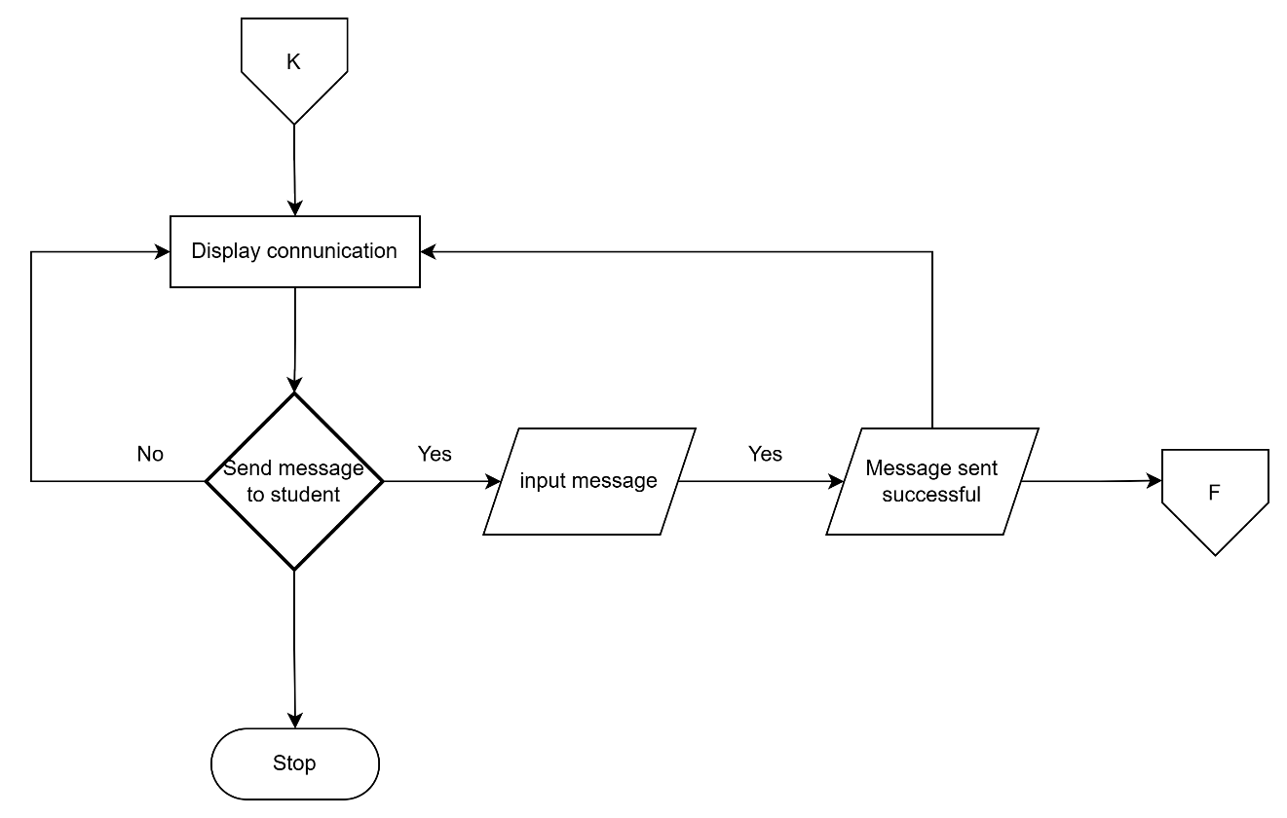

**Figure 36:** Communication/message

**Entity Relation Diagram**

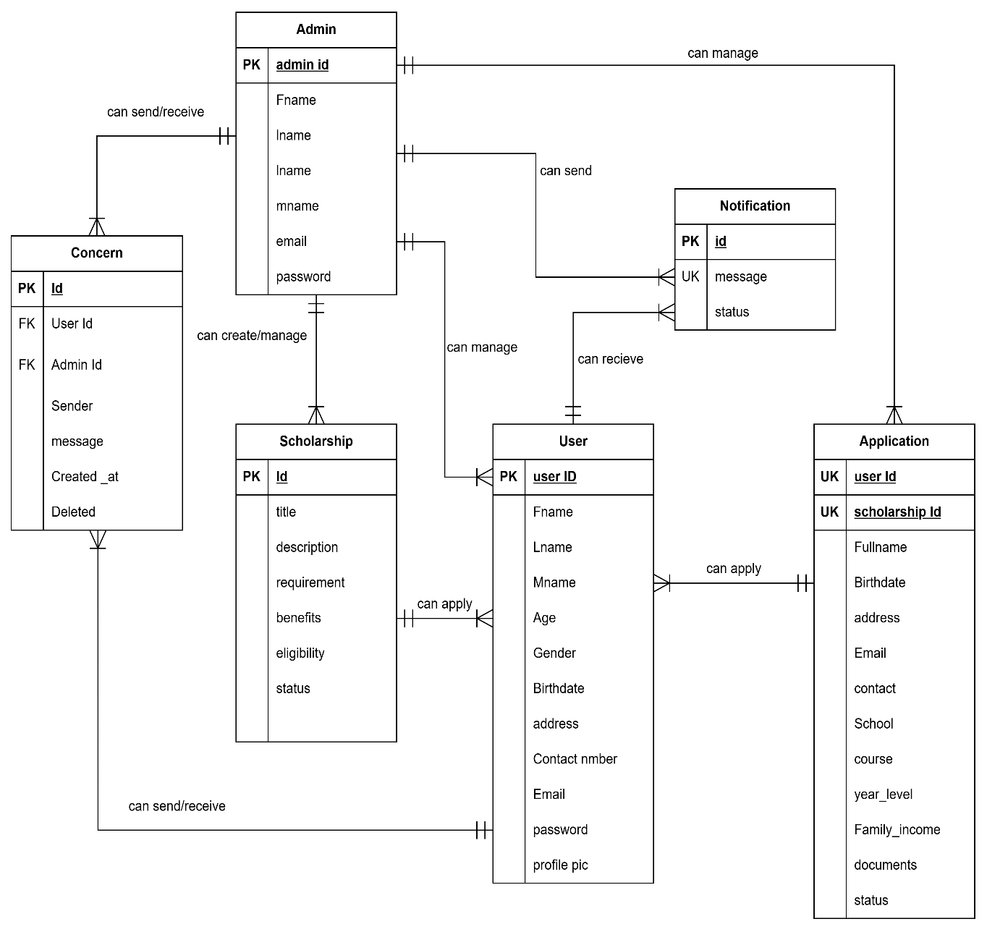

**Figure 37:** Entity Relationship Diagram

**Data Dictionary**

**Table 1** User

|  |  |  |  |  |
| --- | --- | --- | --- | --- |
| **Fields Name** | **Data Type** | **Size** | **Attribute** | **Description** |
| Id | int | 11 | PK | User id |
| Fname | varchar | 20 |  | First Name |
| Lname | varchar | 20 |  | Last Name |
| Mname | varchar | 20 |  | Middle Name |
| Age | int | 3 |  | Age |
| Gender | Varchar | 20 |  | Gender |
| Birthdate | date |  |  | Birthdate |
| Address | varchar | 100 |  | Address |
| contact_number | int | 11 |  | Contact Number |
| Email | varchar | 100 |  | Email |
| Password | varchar | 150 |  | Password |
| reset_token | varchar | 255 |  | Reset Token |
| reset_token_expiry | datetime |  |  | Reset Token Expiry |
| profile_pic | varchar | 255 |  | Profile Picture |

**Table 2** Admin

|  |  |  |  |  |
| --- | --- | --- | --- | --- |
| **Fields Name** | **Data Type** | **Size** | **Attribute** | **Description** |
| Id | Int | 11 | PK | Admin id |
| fname | varchar | 20 |  | First Name |
| lname | varchar | 20 |  | Last Name |
| Mname | varchar | 20 |  | Middle Name |
| Email | varchar | 20 |  | Email |
| password | varchar | 150 |  | Password |

**Table 3** Notifications

|  |  |  |  |  |
| --- | --- | --- | --- | --- |
| **Fields Name** | **Data Type** | **Size** | **Attribute** | **Description** |
| Id | Int | 11 | PK | Notification id |
| message | text |  | UK | message |
| deadline | datetime |  |  | Deadline |
| user_id | int | 11 |  | User_id |
| status | enum (“unread”, ”read”) |  |  | Status |
| created_at | timestamp |  | UK | Created At |

**Table 4:** Scholarships

|  |  |  |  |  |
| --- | --- | --- | --- | --- |
| **Fields Name** | **Data Type** | **Size** | **Attribute** | **Description** |
| Id | Int | 11 | PK | Scholarship id |
| title | varchar | 255 |  | Title |
| description | text |  |  | Description |
| requirements | text |  |  | Requirements |
| benefits | text |  |  | Benefits |
| eligibility | text |  |  | Eligibility |
| status | enum (“pending”, “Active”) |  |  | Status |
| created_at | timestamp |  |  | Created At |
| updated_at | timestamp |  |  | Updated At |

**Table 5:** Application

|  |  |  |  |  |
| --- | --- | --- | --- | --- |
| **Fields Name** | **Data Type** | **Size** | **Attribute** | **Description** |
| Id | Int | 11 | PK | Application Id |
| user_id | Int | 11 | UK | User Id |
| scholarship_id | Int | 11 | UK | Scholarship Id |
| fullname | varchar | 255 |  | Full Name |
| birthdate | Date |  |  | Birthdate |
| address | Text |  |  | Address |
| email | varchar | 255 |  | Email |
| contact | int | 11 |  | Contact |
| school | varchar | 255 |  | School |
| course | varchar | 255 |  | Course |
| year_level | varchar | 50 |  | Year Level |
| family_income | decimal (10.2) |  |  | Family Income |
| documents | text |  |  | Documents |
| status | enum (“pending”, “approved”, “rejected”) |  |  | Status |
| created_at | timestamp |  |  | Created At |
| updated_at | timestamp |  |  | Updated At |

**Development**

The PESO San Julian MIS followed a systematic and iterative approach, ensuring that all functional and non-functional requirements were met, and the system could be scaled and maintained over time. The development process was divided into several key stages, including planning, design, development, testing deploy, and review, with each stage involving continuous collaboration between stakeholders and the development team.

**Program Specification**

Program specification is a precise statement of the effects that individual program is required to achieve.

**Input Description**

The PESO San Julian MIS collects and processes input data from students, and administrative to manage scholarship applications efficiently. The system requires the following inputs

* Student Information
* Scholarship/SPES Application Details
* System Administrator Input

**Output Description**

The output of the system are application status update, application review dashboards, verification status Reports

**Data structure description**

The PESO San Julian MIS employs a relational database structure designed to manage user accounts, scholarship applications, document submissions, and administrative actions efficiently. The core data entities include users, applications, notifications, users table stores basic account information for all system participants, including roles such as students, reviewers, and administrators. Scholarship Applications table records application data, including submission dates and statuses,

**Program description**

The PESO San Julian MIS was developed using a combination of web-based programming languages and modern development frameworks to ensure a responsive, scalable, and user-friendly platform. The frontend was developed using HTML, CSS, PHP, and JavaScript, his allowed for real-time updates, responsive design across devices, and smooth navigation for users such as students, reviewers, and administrators.

**Programming Environment**

**HTML Hypertext Markup Language** is the standard markup language used to create and structure content on the web. It forms the basic building blocks of web pages by defining elements such as headings, paragraphs, links, images, and other multimedia.

**CSS Cascading Style Sheets** is a style sheet language used to control the visual presentation of HTML documents. It allows developers to apply styles such as colors, fonts, spacing, and layout to web pages, ensuring consistency and responsiveness across devices.

**PHP Hypertext Preprocessor** is a widely-used open-source server-side scripting language designed specifically for web development. It can be embedded within HTML to manage dynamic content, interact with databases, and handle server-side logic.

**JavaScript** is a high-level, text-based programming language that enables interactive and dynamic content on websites. It can run both on the client side allowing developers to create responsive user interfaces, validate forms, update content in real time, and more.

**Research Design**

The evaluation of the PESO San Julian MIS is grounded in a developmental research approach, a methodology often used in the field of instructional and systems design, which emphasizes iterative development, continuous testing, and improvement of technological solutions. This approach was selected because it supports the creation of functional, user-centered systems that respond to real-world needs through ongoing feedback and refinement.

**Research Locale**

The study was conducted at Municipality of San Julian Eastern Samar, Philippines.

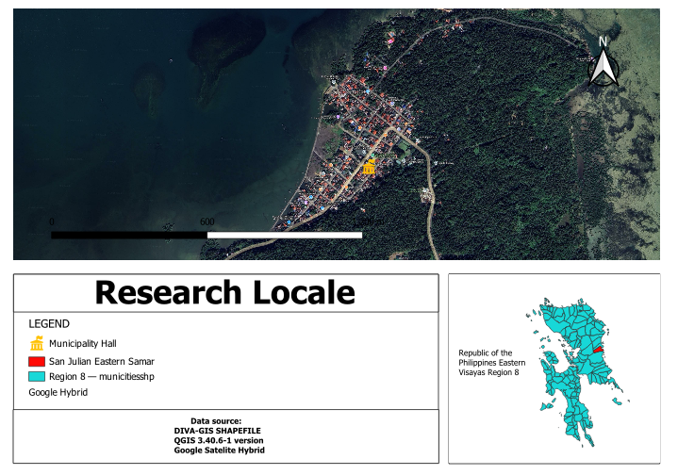

**Figure 38:** Research locale

**System Architecture**

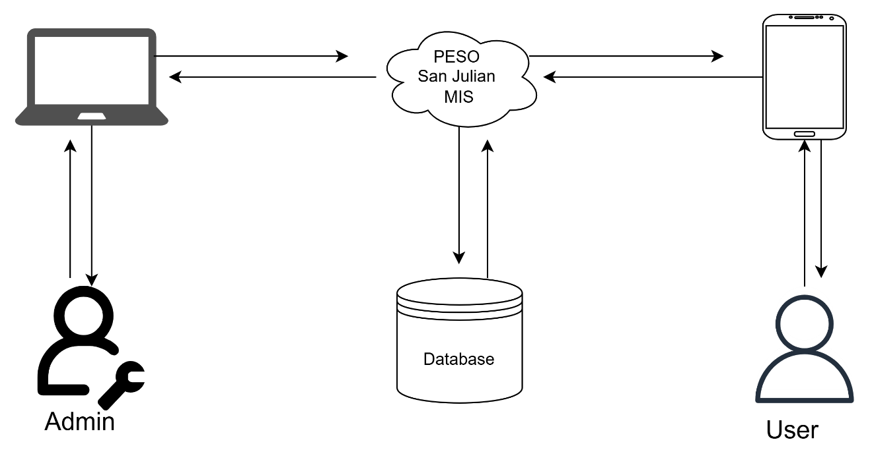

**Instrumentation**

This system, a variety of instruments were developed and applied. User survey was created to measure the ease of use, overall satisfaction, and perceived system efficiency from the perspectives of students and scholarship in charge. During user testing sessions, observation checklists were used to systematically monitor user interactions, identify navigation difficulties, and document any system errors encountered. In addition, system logs and metrics were automatically generated to record user activities, track system performance, measure uptime, and highlight error occurrences, all of which supported a comprehensive performance evaluation. Test cases and scripts were used by developers to evaluate each feature of the system in a consistent and structured manner, ensuring that all components met functional and technical requirements.

**Data Analysis**

The data collected during the testing and evaluation phase of the PESO San Julian MIS were analyzed using a combination of statistical and thematic methods to ensure a thorough understanding of both system performance and user experience.

The answers from the Computer Usability Satisfaction Questionnaire will be analyzed using average scores. Each question will be rated using a scale (, 1 to 5), and the scores will be added and divided to obtain the average. These averages will help determine how easy the system is to use, how well it works, and how satisfied the users are. The results will show whether the system meets the users’ needs and expectations.

**Unit Testing**

Each individual module of the PESO San Julian MIS was tested in isolation to verify that it performed as expected. Each unit was tested with multiple inputs and edge cases to ensure accuracy, reliability, and proper error handling.

* User Registration and Login
* Scholarship Application Form Submission
* Document Upload Functionality
* Verification Workflow
* Notification System
* Admin Panel and Reporting Tool

**Integration Testing**

After verifying the individual modules, the researcher they were combined to test data flow and communication between components. This ensured the entire system worked together seamlessly, such as how student data flowed from application to verification to disbursement. Integration testing helped uncover previously unnoticed issues related to system timing, data validation, and error handling. Delays in communication between modules, inconsistent data formatting, or improper error messages were all identified and resolved during this phase.

**System testing (Alpha test)**

Alpha testing was conducted by the development team in a controlled environment. The aim was to identify and fix bugs, performance issues, or errors before releasing the system to real users. The researcher used alpha testing to assess the responsiveness and efficiency of the user interface. Monitored how quickly pages loaded, how smoothly transitions occurred, and whether the layout was user-friendly and intuitive. Special attention was given to security aspects, particularly data validation and protection, as the system handles sensitive student and institutional information

**Acceptance Testing (Beta Test)**

This stage was essential for assessing how well the system performed in an actual operational setting and determining its readiness for full-scale implementation. The users involved in this phase included students applying for scholarships and SPES, school personnel responsible for verifying applications, and administrative staff tasked with evaluating and approving the application.

During beta testing, users were asked to engage with the system under realistic conditions registering accounts, filling out scholarship application forms, uploading documents, tracking their application status, built-in messaging system. This allowed the development team to observe how effectively the system supported the entire scholarship lifecycle, from submission to final approval

**Implementation**

The system will be developed and made available for use by both the PESO in charge and students. It will be implemented as a web-based platform that enables students to manage their scholarship applications, view updates, and receive announcements. Meanwhile, PESO in charge will be able to post announcements, review applications, and oversee the entire process PESO San Julian MIS. The implementation was carried out gradually, providing sufficient time to gather real-world feedback from users and make necessary adjustments before expanding the system to a wider audience. Continuous support and system monitoring played a crucial role in ensuring a smooth and effective transition from manual to digital scholarship/SPES processing. To ensure the system functions efficiently, specific software and hardware requirements must be met. On the software side, the platform will run on major operating systems such as Windows 10/11, macOS, or Linux. Users will need access to modern web browsers Google Chrome, or Microsoft Edge. The backend may be powered by frameworks .Java script (PHP), while the frontend will utilize standard web technologies such as HTML5, CSS3, and JavaScript,. The system will rely on a database management system such as MySQL, or MongoDB. In terms of hardware, client devices used by students and PESO in charge should have at least an 4GB of RAM and 64GB of mobile phone and Intel Core i3 processor, 4GB of RAM, and 100 GB of free disk space, along with a stable internet connection. For server hosting, whether self-hosted or cloud-based, the system should be supported by a machine with a quad-core 2.5 GHz processor or higher, at least 8 GB of RAM (16 GB recommended), and 250 GB or more of SSD storage.